

Report in

Software project about Healthy lifestyle
Instructor : Dr. Islam El-gedawy

Student name : Tasneem Ibrahim Hassan Mohamed Taha(PM)
Abdulrahman Hamby Khalil Shehata Harb
Rokia Islam Elsayed Hussein Elsayed Ali
Mariam Mohamed Sobhy Mohamed Othman
Raghad Mohamed Ahmed Mohamed AbuRafai
Student’s ID : 22101382
22100692
22101084
22100778
22101912
Faculty : Computer science and engineering (CSE)
Level : Three Semester : Fall 2025
Course name : Software Engineering Course code : CSE251

- Tasneem
Tasneem.mohamed.2023@aiu.edu.eg
Manage Payment
- Abdulrahman
abdelraheman.shehata.2023@aiu.edu.eg
Manage goal
- Rokia
rokia.hussein.2023@Aiu.edu.eg
Manage premium subscribers
- Mariam
Mariam.othamn.2023@aiu.edu.eg
Manage nutrition intake
- Raghad
raghad.mohamed.2023@aiu.edu.eg
Manage session

Milestone 1
- Problem define and solution
- In today’s society, several barriers prevent individuals from maintaining a healthy lifestyle, even though the desire to improve physical fitness is widespread. One major problem is the lack of time to visit a gym. People with demanding work or personal schedules often struggle to incorporate consistent workouts into their daily routines, limiting their opportunities to stay fit.
- Another significant issue is gym anxiety, a scientifically recognized condition where individuals feel uncomfortable or intimidated in gym environments. This anxiety can stem from concerns about judgment, lack of confidence, or feeling out of place, leading many to avoid gyms altogether.
- Additionally, obesity and excessive body fat remain prevalent health issues, with many individuals seeking ways to manage their weight but lacking effective, accessible solutions. Even for those who do go to the gym, a lack of knowledge about proper exercise techniques often leads to ineffective or potentially harmful workouts. This gap in understanding prevents many from achieving their fitness goals and contributes to further frustration.
- These challenges—time constraints, gym anxiety, weight management struggles, and lack of exercise knowledge—create a significant barrier to achieving and maintaining a healthy lifestyle. Our project seeks to address these problems by offering a practical, guided solution to make fitness more accessible and less intimidating for everyone

- Project Title
Healthy Lifestyle

- Project Description
- The Lifestyle Application System is a comprehensive digital platform designed to enhance users' daily lives by promoting healthier habits, improving productivity, and fostering overall well-being. By integrating various tools and features, this system helps users effectively manage their physical and mental health through a highly personalized experience.

- Users input personal data such as height, weight, age, and food preferences, allowing the system to generate meal suggestions that align with their unique needs. The application also counts calories, providing insights into daily calorie intake to help users stay on track with their nutrition goals. Additionally, it tracks workout progress it provides score on the user's daily achievements of fitness goals, fostering motivation and accountability.

- The application provides tailored content, recommending relevant resources and activities based on each user’s specific situation and progress. Through intuitive design and adaptive algorithms, the system empowers users to track their overall health journey, receive real-time feedback, and access resources that support their health and lifestyle goals.

- A premium subscription, which can only be paid using cards, enables users to communicate directly with health coaches or doctors for personalized guidance and expert advice. Overall, the Lifestyle Application System equips users with the tools they need to lead a more balanced, fulfilling, and organized life.

- The system ensures that users receive clear and transparent billing information detailing the charges for services provided by both doctors and coaches. For each session or service, the system will automatically deduct a 20% platform fee from the earnings of the doctors and coaches. This transparent process allows users to understand the exact cost of services, while doctors and coaches can track their earnings after the platform's deduction, ensuring smooth and accurate financial transactions.

- Requirements

Customer requirements
- users log in(user_name,password or email, password)
- Users input their personal data(height,weight,age,gender)
- users can edit their personal data(height,weight,age,gender)
- Users should be able to delete or deactivate their accounts if desired with appropriate security measures in place to protect their data.
- Users are able to input personal metrics such as height, weight, and food preferences at any time.
- Users are able to edit and update input such as height, weight, and food preferences at any time.
- Users are able to track physical Duration of the exercise
- Users are able to track Calories burned.
- Users will receive meal suggestions tailored to their input data (height, weight, food preferences, and health goals).
- Users are able to view instructional videos and guides for each exercise.
- User is able to log meals consumed daily to calorie intake.
- Users are able to set and update health goals.
- Users can view progress towards their goals through visual feedback, including Progress bars.
- Premium users have access to health coaches or doctors for personalized guidance.
- Users are be able to pay for premium services securely using cards, manage their subscriptions.
- Premium users have access to health coaches or doctors for personalized guidance.
- Users are be able to cancel their subscription.
- User will receive tips or suggestions to improve their fitness and nutrition.
- The user can log in through multiple devices.
- The users are alerted when they deviate from their health goals or targets.
- Premium Users are able to open meetings securely with health coaches, doctors.
- Users can regularly back up user data and in case of data loss or corruption.
- Users receive clear billing information detailing the charges
- Doctors are be able to create personalized meal plans for users based on their health data (e.g., height, weight, dietary preferences, and goals).
- Doctors should be able to update and modify existing meal plans for users as needed.
- Coaches must be able to create and upload personalized training plans for users based on their fitness goals, experience level, and available equipment.
- Coaches are able to access users' workout logs, including the types of exercises done, time spent, and performance scores, to better understand user progress.
- Coaches are able to receive payments through the platform, with the system deducting 20% of their earnings for platform fees.
- Doctors are able to receive payments through the platform, with the system deducting 20% of their earnings for platform fees.

Software requirements

Functional

User Registration and Authentication
The system must provide secure account creation and login via email, mobile, or social media platforms (e.g., Google, Facebook).
Users must have the option to reset passwords and recover accounts through secure methods.

Profile Management
Users must be able to create, view, and update personal profiles, including height, weight, age, gender, and food preferences.
Users should have the ability to delete or deactivate their accounts if needed.

Personal Data Input
The system must allow users to input personal metrics such as height, weight, and food preferences, which are used to generate personalized plans.
Users should be able to update or modify their personal data at any time.

Fitness Tracking
The system must track users’ physical activity, including exercise duration, intensity, and calories burned.
The system should allow integration with third-party wearable devices (e.g., fitness trackers, smartwatches) for automatic tracking.

Meal Planning and Tracking
The system must generate meal suggestions based on user input (height, weight, food preferences, and goals) and allow users to log consumed meals.
Users should be able to customize meal plans and replace suggested items with alternatives.

Goal Setting and Progress Tracking
The system must allow users to set and update personal health goals (e.g., weight loss, muscle gain, mental health goals).
It should track users’ progress toward these goals and provide visual feedback (e.g., charts, progress bars).
Personalized Content Recommendations

The system must provide personalized content
(e.g., workout tips, nutritional advice, wellness articles) based on users’ data and activity.
It should use adaptive algorithms to recommend content that matches users' preferences, goals, and progress.

Premium Subscription Services
The system must provide a premium subscription option where users can communicate with health coaches or doctors via chat or video calls.
It should support secure payments for premium services, allowing users to upgrade, downgrade, or cancel subscriptions.

Notifications and Alerts
The system must allow users to customize notification frequency and types, such as motivational reminders or goal-based alerts.

Real-Time Feedback
The system must provide real-time feedback based on user inputs and activities, such as calorie consumption or workout performance.
It should offer suggestions or tips to improve users' fitness, nutrition, or mindfulness routines.

Exercise Library
The system must contain a library of exercises categorized by body part, equipment, or fitness goals.
Users should be able to access instructional videos and guides for each exercise.

Data Synchronization
The system must synchronize user data across multiple devices (e.g., mobile app, web browser) to ensure consistent access to profiles and progress reports.
Users should be able to access their data on any platform where the application is available.

Health Metrics Monitoring (daily)
The system must allow users to log and monitor their health metrics, including weight, BMI, calorie intake.
Users should receive alerts if they deviate from their health targets.

Security and Data Privacy
The system must ensure secure storage of user data, implementing encryption and compliance with relevant data protection regulations (e.g., GDPR).
Users must have control over their privacy settings, with the ability to delete or download their data.

In-App Messaging
The system must provide in-app messaging for users to communicate with coaches, doctors (premium service), or technical support.
Messages should be stored securely, ensuring user privacy.

Data Backup and Recovery
The system must perform regular backups of user data to prevent loss in case of technical issues.
It must provide users with the option to recover or restore their data if lost or corrupted.

Revenue Sharing with Coaches and Doctors
The system must automatically deduct and retain 20% of the fees earned by coaches and doctors for services provided through the platform.
Users should receive transparent billing information detailing the charges and deductions related to coaching services.

User Ranking System
The system must include a scoring mechanism that calculates both local and worldwide scores for each user based on their activities, achievements, and participation in challenges.
Users should have the option to choose a unique username that will be publicly visible in the rankings, allowing them to see their position among other users globally and locally.

Gender-Specific Coaching Options
The system must provide the option for users to select coaches based on gender preferences, ensuring that female coaches are available for female users and male coaches for male users.
Users should be able to filter search results to view only coaches that align with their gender preferences.

Non-Functional:

Publicly Visible Health Data
The system will not make any personal health metrics (such as weight, BMI, or calorie intake) publicly visible to other users. All health data will remain private unless the user explicitly chooses to share it with a coach or doctor. Personal Medical Diagnosis
The system will not provide any formal medical diagnosis or treatment plans. Users are encouraged to consult healthcare professionals for any medical conditions or specific treatments.

Offline Functionality
The application will not fully function offline. While some data may be cached for temporary use, most features, such as real-time feedback, data synchronization, and communication with coaches or doctors, will require an internet connection.

Custom Exercise Plans for Medical Conditions
The system will not create customized workout plans for users with medical conditions or disabilities without guidance from healthcare professionals. Users with specific conditions must seek personalized advice from their doctors

Guaranteed Results
The system will not guarantee specific outcomes, such as weight loss or muscle gain. While the application provides guidance and tracking, achieving fitness goals depends on individual effort and circumstances.

Third-Party Advertising
The system will not include third-party advertisements, maintaining a focus on user experience without interruptions from external promotions.

Availability of Health Coaches/Doctors
Premium users will have access to health coaches and doctors, but the system will not guarantee 24/7 availability. Availability of professionals will be subject to their schedules.

Free Unlimited Access to Premium Features
The application will not offer unlimited access to premium features (such as consultations with coaches or doctors) without subscription. Users must subscribe to access these services, and certain features will be restricted in the free version.

Dietary Supplements or Medical Products
The system will not sell or recommend any specific dietary supplements or medical products. Nutritional advice will focus on balanced meals and healthy eating, without promoting specific brands or products.

Manual Data Entry for Wearable Devices
Users will not be required to manually enter data from wearable fitness devices (such as smartwatches or fitness trackers). The system will automatically sync data from supported devices.

- Subsystems Define
Subsystem Name | Subsystem Function | Subsystem interface
User Management Subsystem | - Signup() : This method handles the user registration process, collecting the user's first name, last name, email, phone number, and password.  - Login() : Authenticates users by verifying their email/username and password.  - resetPassword() : Allows users to reset their password by providing either an email or a phone number.  - viewProfile() : Allows users to view their profile details (e.g., height, weight, age, food preferences).  - updateProfile() : Enables users to update their profile information.  - deleteAccount() : Allows users to deactivate or delete their account. | - Interface manage_Authentication{ Void signup (String firstName, String lastName, String email, String phoneNumber, String password);  Void login (String email, String password);  Void resetPassword (String emailOrPhone);  }  - Interface manage_Profile{  Void viewProfile()  Void updateProfile()  Void deleteAccount(String password);  }
Coach Management System | - uploadTrainingPlan() : Allows coaches to upload custom training plans for their trainees.  - trackPrivateSession() : Tracks private coaching sessions, including session details like time, type, and the trainee’s performance.  - trackTraineeProgress(): Allows coaches to monitor trainee progress over time, comparing current stats to their goals. | - Interface CoachTrainingPlanInterface {  void uploadTrainingPlan(String coachId, TrainingPlan plan);  void trackTraineeProgress(String traineeId); }  - interface CoachSessionManagementInterface {  void trackPrivateSession(String sessionId, SessionDetails details);  }
Doctor Management System | - uploadMealPlan() : Doctors can upload personalized meal plans for users based on their health data.  - trackPrivateSession() : Tracks private sessions between doctors and users, including details such as session type and progress reports.  - trackUserProgress() : view user progress in terms of diet and overall health, providing feedback to users. | - interface DoctorMealPlanInterface {  void uploadMealPlan(String doctorId, MealPlan plan);  void trackUserProgress(String userId);  }  - interface DoctorSessionManagementInterface {  void trackPrivateSession(String sessionId, SessionDetails details); }
Booking Session Management Subsystem | - bookSession() : Allows users to book sessions with a coach or doctor based on availability.  - searchSessions() : Allows users to search for available sessions by coach, doctor, or time slot.  - filterSessions() : Users can filter available sessions based on preferences such as coach/doctor gender or session type. | - Interface ManageSession {  void bookSession(String sessionId, String userId);  }  - Interface ManageSearch {  void searchSessions(String Wanted_session);  void filterSessions(String Filter_name);  }
Session management  subsystem | - create session():Allows Doctor /coach  to create a new session  - modify session(): Allows Doctor /coach to modify sessions  - delete session(): Allows Doctor /coach to delete sessions | - Interface Manage_session {  void createSession(String sessionId,String InstructorID, int capacity, date date ,time time)  void modifySession(String sessionId,String InstructorID, int capacity, date date ,time time)  void deleteSession(String sessionID)  }
Fitness Tracking Subsystem | - view progress(): visualize user  progress since start of using the app  - view remaining (): allows user to see what is remaining to reach their goal | Interface Fitness_tracking{  void viewProgress(int userid);  void viewRemaining(int userid);}
Meal Planning Subsystem | - MealSuggestions() : Provides users with meal suggestions based on their nutrition preferences and health goals.  - customizeMealPlan() : Allows users to customize meal plans by adding or replacing ingredints. | - Interface MealPlans {  void customizeMealPlan(String userId, String ingredints);  void MealSuggestions(String nutrition preferences )  }
Manage Notification Subsystem | - CustomizeNotificationSettings() : Allows users to customize the type of notifications they receive.  - sendNotifications() : Sends motivational notifications or alerts based on user progress and goals. | - Interface ManageNotification{  void customizeNotificationSettings(String userId, NotificationSettings settings);  void recieveNotifications(String userId, String notificationType);  }
Review Subsystem | - MakeReview() : Allow users to make their review about the sessions either with doctors or with coaches. | - Interface ManageReview {  void MakeReview(String userId, Review Review);  }
Recommendation Subsystem | - recommendContent() : Recommends personalized content such as workout tips, nutritional articles, and wellness advice based on user data.  - searchExercises() : Allows users to search for exercises based on body part or equipment. | - Interface ManageRecommendations {  void recommend content ();  void SearchExercises(String Excersise);  }
Premium service subsystem | - view offered plans  - view each plan details | - InterfacePremium service interface {  void plans ();  void plan_details(int planID);  }
Inbody management subsystem | - void trackInbodyMeasurments():  Allows user to track his fitness by taking his In body measurements each month | InterfaceInbody _management {  void trackInBodyMeasurements(String userId, BodyMetrics metrics, Date date );  }
Goal management subsystem | set goal(): allows user to set a goal weight for a specific date  modify goal(): allows user to modify their goal | Interface Goal_mangement {  void set_goal ( int userid , date date , float goal_weight );  void modify_goal ( int userid , date date , float goal_weight );}
Chat management subsystem | - create chat():allows user to create a new chat  - enter chat (): allows user to enter existing chat  - leave chat():allows user to leave a chat  - add member(): allows user to add other users to the chat  - send message():allows user to send a message in chat | Interface Chat_mangement{  void create_chat(int userid, string chat_name,png chat_image);  void enter_chat(int userid, int chatID);  void leave_chat(int userid, int chatID);  void add_member(int chatID, int userid,int new_memberID);  void send_message (int chatID,int userid,string message , date date );}
Payment management subsystem | - make payment(): allows user to pay for their subscription plan  - cancel payment (): allows user to cancel their payment | Interface Payment_Mangment{  void make_payment(int userid,int cardno,string subscribtion_plan);  void cancel_payment(int userid,int cardno,string subscribtion_plan);}
Social media community subsytem | - make a post(): allows user to create a new post  - delete a post(): allows user to delete a post  - comment on a post (): allows user to comment on a post  - react to a post (): allows user to react to others posts | Interface Social_media{  void make_post (int userid,string content , date date );  void delete_post(int postID);  void comment (int postID,int userid,string comment , date date );  void React (int postID,int userid,string reaction , date date );}
Nutrition intake management | - trackNutritionalIntake() : Tracks the daily nutritional intake (calories, proteins, fats, etc.).  - trackWaterConsumption() : Tracks the amount water consumed by the user each day. | - Interface ManageNutritionIntake {  void trackCalorieIntake(String userId, int calories);  void trackWaterConsumption(String userId, double waterAmount);  }
Excersise tracking subsytem | - trackExercise() : Tracks the user's daily exercise, including duration, intensity, and calories burned. | - Interface track_Excersise{  void trackExercise(String userId,String Exercise_type,String Exercise_intenisty,int Exercise_duration,Float calories ); }

- Traceability Matrix :

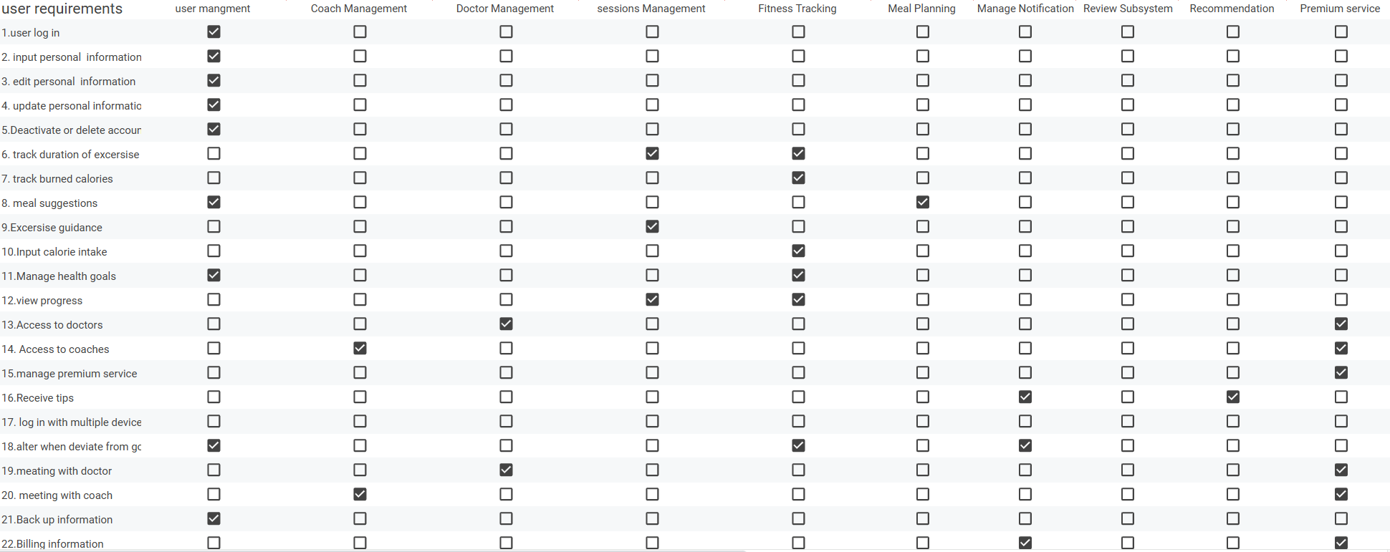
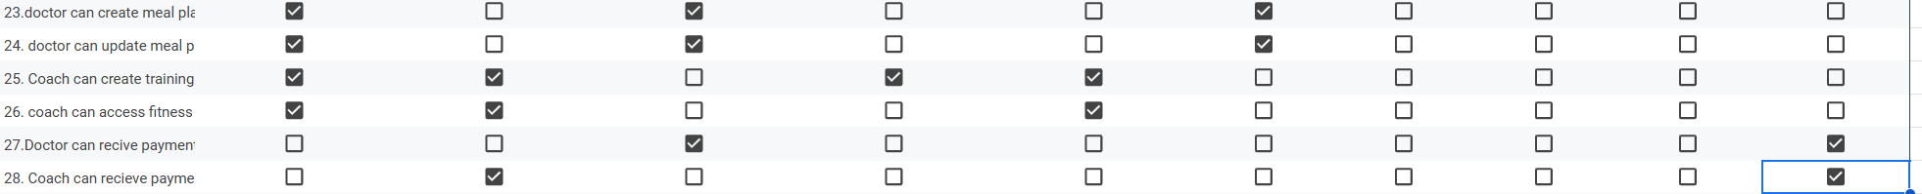

link: https://docs.google.com/spreadsheets/d/1LExNz0TyXbZ0pnsMFBl3Qs56f05Bgi7rc1ixAe5rg_k/edit?usp=sharing

- Use cases diagram
Before update
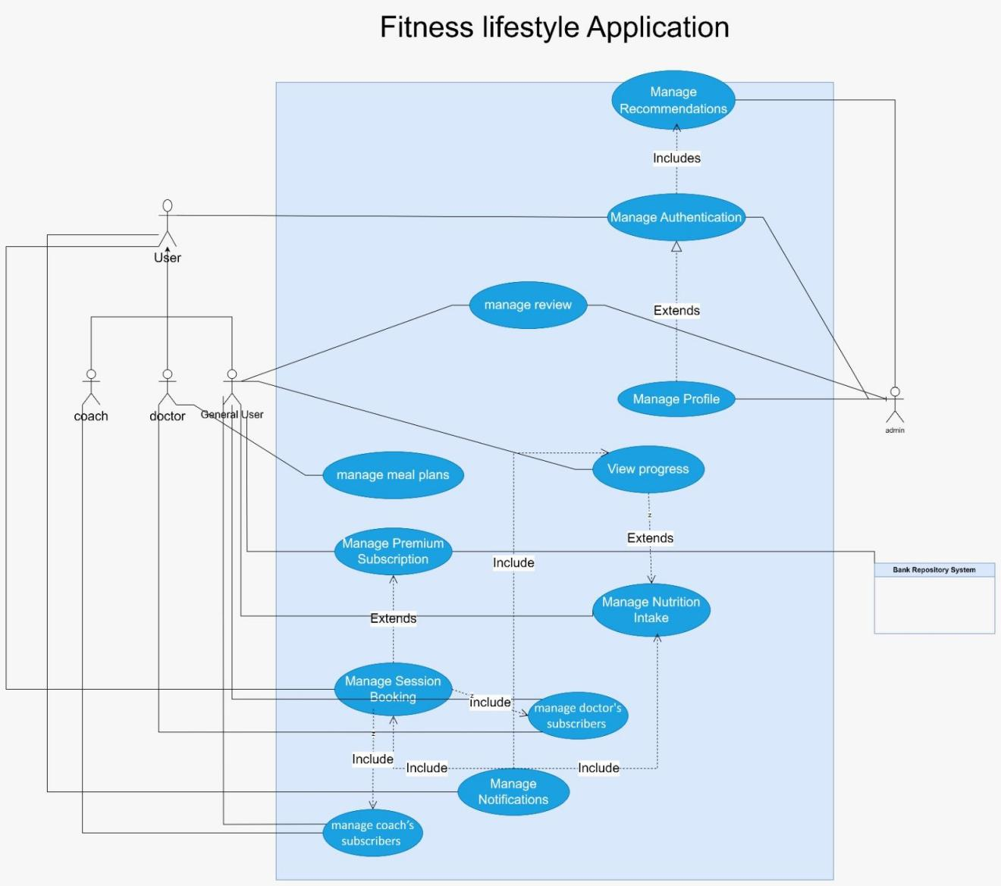

Ater update
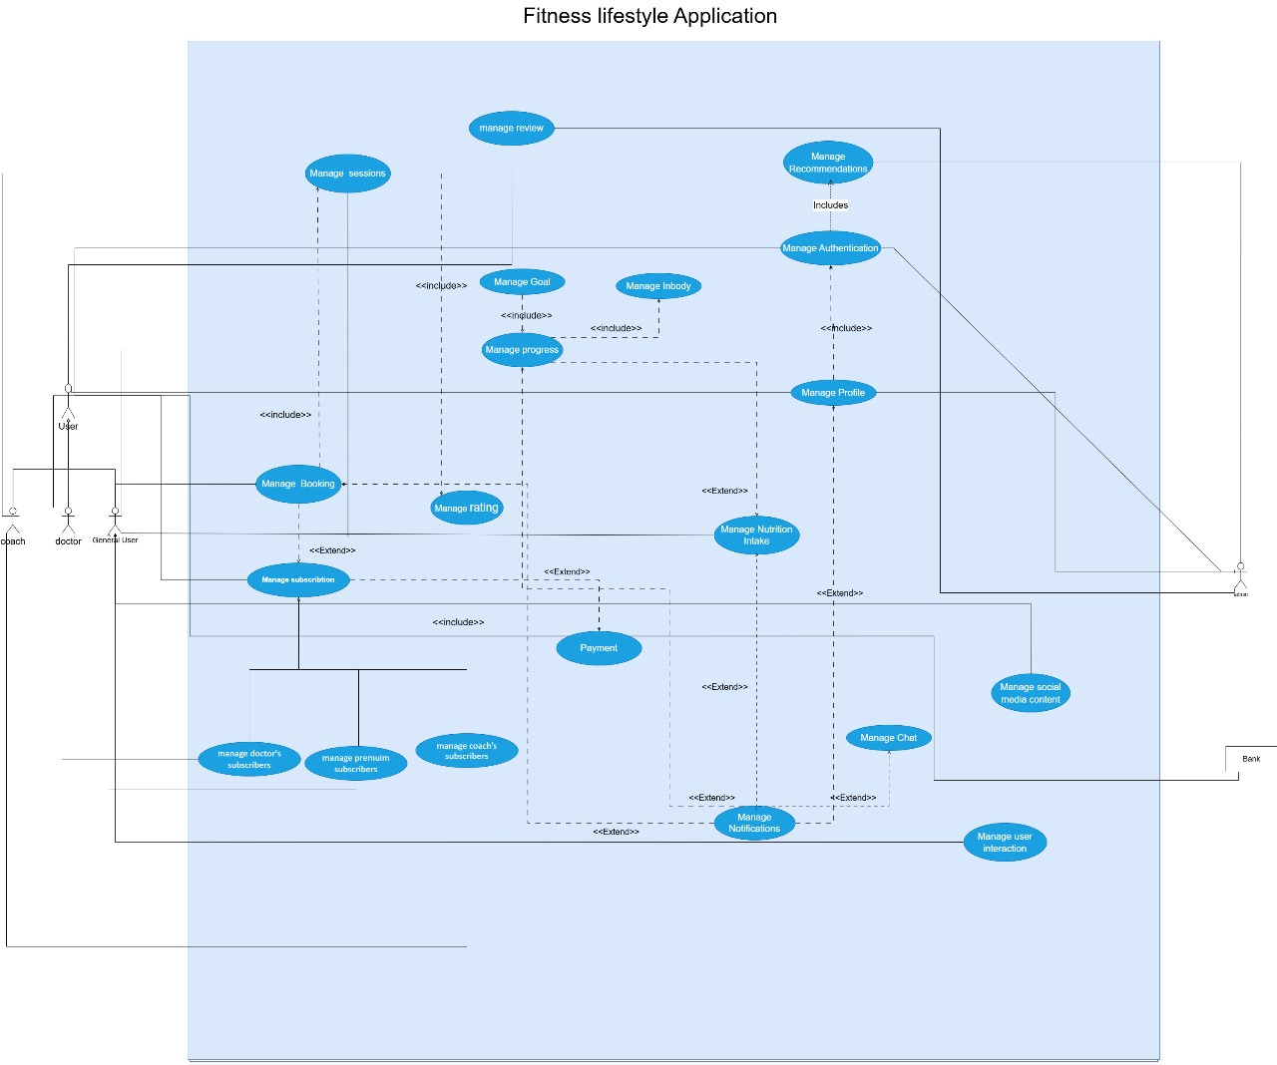

- Use Cases

Core Use Cases (Essential Features)
- Manage Authentication - Essential for accessing the app securely.
- Manage Profile - Essential for personalizing user data.
- Manage Nutrition Intake - Essential for helping users track and manage their diet.
- View Progress - Essential for showing users their progress for their goals.

Important Use Cases

- Manage Content - Essential for providing users with suggested content
- Manage Premium Subscriptions - Essential for accessing premium features that offer personalized coaching and doctor consults.
- Manage Session Booking - Essential for booking sessions with either doctors or coaches which is allowed for the premium subscribers.
- Manage Notifications - Essential for providing users with reminders and alerts to keep users on track.
- Manage Meal Plans - Essential for allowing users to see many meal plan suggestions.

Non-Core Use Cases (Additional Features)
- Manage Coach’s Subscribers - for allowing coaches to track their subscribers and make them more suitable training plans.
- Manage Doctor’s Subscribers- for allowing doctors to track their subscribers and make them more suitable meal plans.
- Manage Reviews - Allows users to give feedback to doctors, coaches or even the app itself, which is useful for app improvement but not essential for user goals.

- Use Case 1: Manage Authentication.
- Use Case Name: Manage Authentication.
- Actors: User (initiator)
- Type: Primary and essential
- Description:
- The user navigates to the login page.
- The system displays the login form with fields for username/email and password.
- The user enters their credentials and submits the form.
- The system validates the credentials against the user database.
- If the credentials are valid, the system authenticates the user and redirects them to the home page or their profile page.

- Cross Ref: Requirements F1, G2, H3
- Preconditions: User is not currently logged in to the system
- Postconditions:
  - User is successfully logged in or registered.
  - The user's session is established.
  - The user is redirected to the appropriate page.

- Alternate Scenarios:
- If the credentials are invalid, the system displays an error message prompting the user to re-enter their credentials.
- The system prompts the user to enter their email address.
- If the email address is valid, the system sends a password reset link to the user's email address.
- The user clicks on the reset link and enters a new password.
- The system resets the user's password and redirects them to the login page.
- If the user does not have an account, they can click on the "Sign Up" link.
- The system displays the registration form with fields for username/email, password, and other required information.

- Test requirements

- Authentication Management
  - Login Functionality:
    - validate the system allows users login with valid credentials.
    - validate users can log in from different devices and browsers without issues.
    - Validate The system shall display an error message for invalid login attempts.
    - validate the system locks the account after a specified number of failed login attempts.

1.2 Registration Functionality:
    - validate that new users can successfully register with valid credentials to login app.
    - validate that users receive a confirmation email upon successful registration.
    - validate the system checks for and prevents duplicate usernames and emails during registration.
    - validate the system that usernames and emails are unique during registration.

1.3 Password Reset Functionality:
    - validate that users can request a password reset link via email.
    - validate that the password reset link is valid for a limited time.
    - validate that users can successfully reset their password using the link.
    - validate the system that sent a confirmation email after a password has been successfully reset.

- Test cases
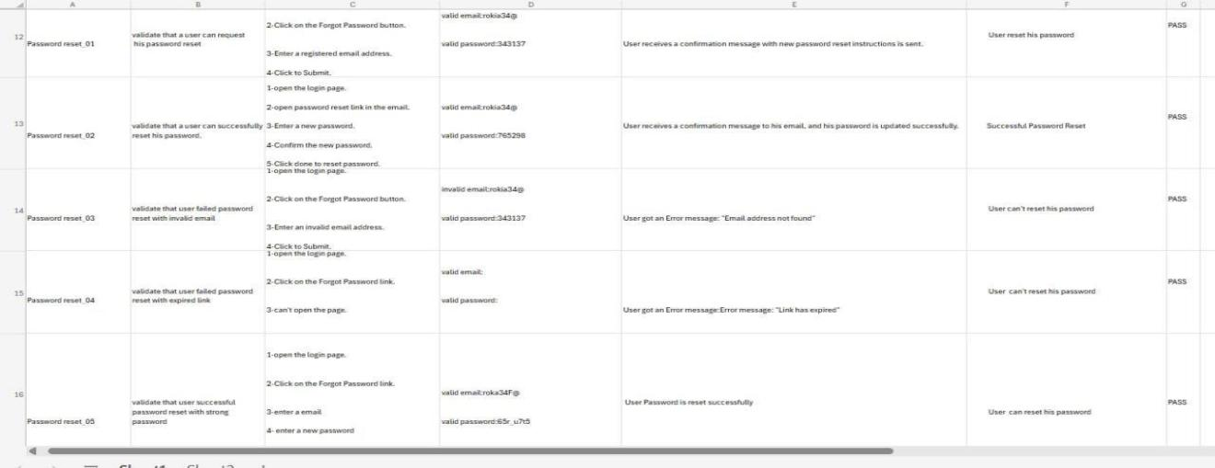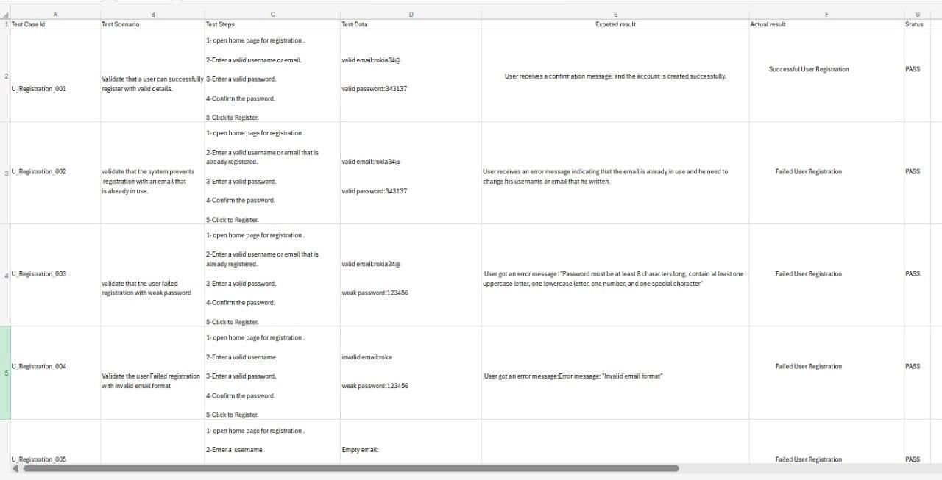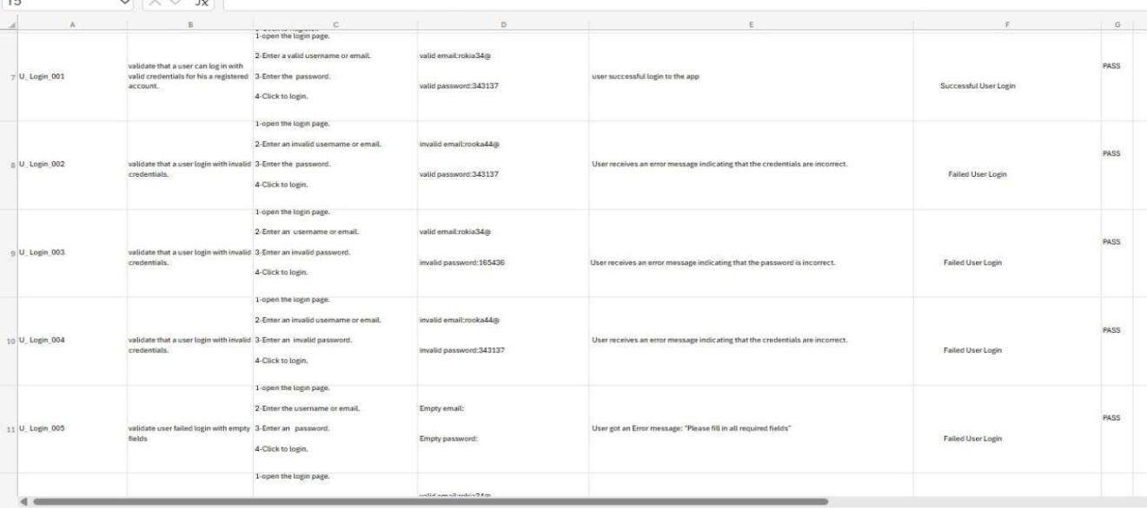
Link: https://1drv.ms/w/s!Aoi3HpDihgkSgQDCXF6I5FJpTt7y?e=p8fzFu
- Use Case 2: Manage Profile.
- Use Case Name: Manage profile
- Actors: User (initiator), Admin
- Type: Primary and essential
- Description:
- The user navigates to their profile page.
- The system retrieves the user's profile information from the database.
- The system displays the following information on the profile page:
Personal Information (name, email, date of birth, etc.)
Fitness Goals (weight loss, muscle gain, etc.)
Activity History (past workouts, progress tracking)
- The user selects the "Edit Profile" option.
- The system displays the user's profile information in editable fields.
- The user makes changes to their profile information.
- The system validates the input data.
- The system updates the user's profile information in the database.
- The system displays a success message or error message, depending on the outcome of the update.

- Cross Ref: User registration
- Preconditions: User is logged into the system.
- Postconditions:
The user's profile information is updated successfully.
The user's profile information is displayed accurately and up to date

- Alternate Scenarios:
- No Profile Information: If the user has not yet provided any profile information, the system displays a message prompting the user to complete their profile.
- Incorrect or Outdated Information: If the user's profile information is incorrect or outdated, the system displays a message indicating the issue and provides options for updating the information.
- Failed Validation: If the user's input data fails validation, the system displays an error message and prompts the user to correct the input.

- Test requirements

- Profile Management
  - View Profile Functionality:
    - validate that users can view their profile information in app after logging in.
    - validate users profile information displayed is accurate and up to date.
    - validate the system that shall display the user's fitness goals, activity history, and personal information.
  - Update Profile Functionality:
    - validate the system that allows users to update their profile information.
    - validate the system shall validate updated information in app.
    - validate the system that shall provide a confirmation message after successful profile updates.
    - validate the system that shall allow users to upload a profile picture.
  - Account Deletion Functionality:
    - validate the system that allows users to request account deletion from their profile settings.
    - validate the system that prompts users for confirmation before proceeding with account deletion.
    - validate the system that permanently deletes the account and all associated data upon user confirmation.
    - validate the system that sends a confirmation email after the account has been deleted.

- Test cases
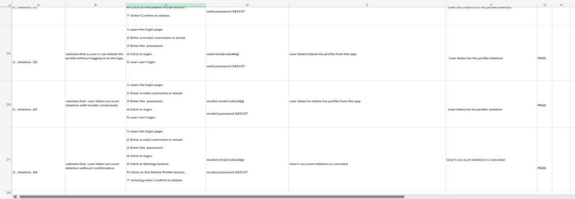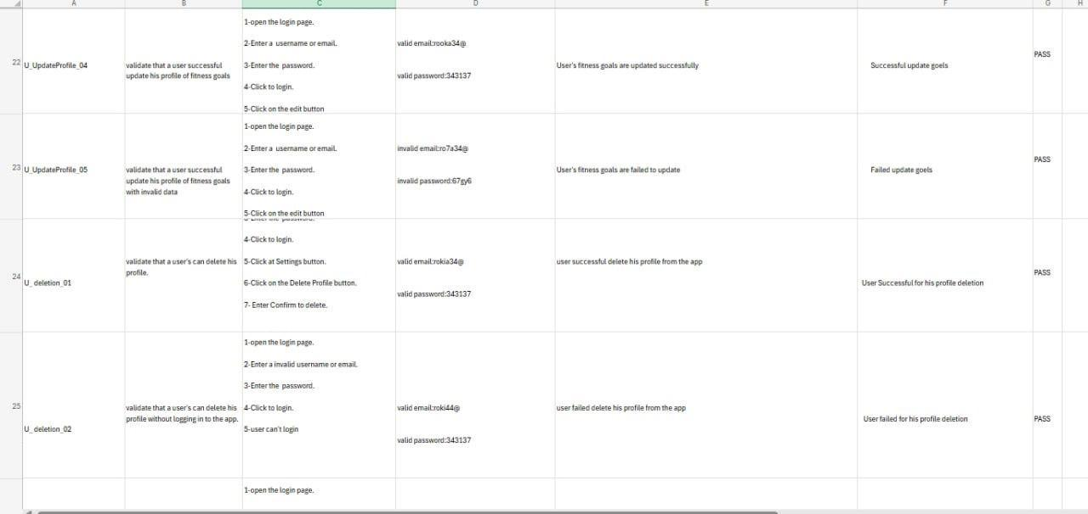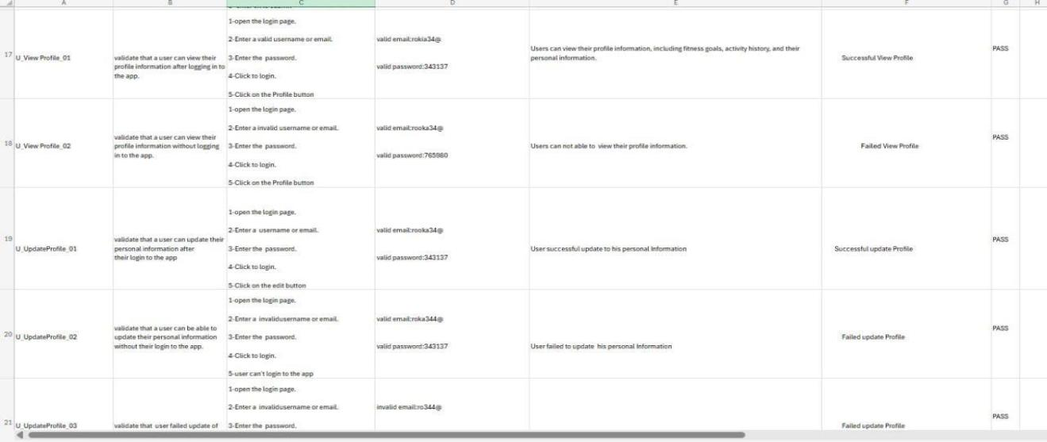
Link: https://aiuedueg-my.sharepoint.com/:x:/g/personal/rokia_hussein_2023_aiu_edu_eg/EXtPISZiy0FEgfCxDA3LNBIBeQHNEWrwkorrUv2onhO47A?e=fhDCef

Use Case 3: Manage Nutrition Intake

Description
- Use Case: Manage Nutrition Intake
- Actors: User
- Type: primary and Essential
- Description:
  - The user accesses the "Nutrition Intake" feature.
  - The user logs the food items consumed throughout the day.
  - The system calculates the total calories and nutritional values.
  - The system provides a summary based on the user’s goals.
- Cross Ref: User registration
- Preconditions: The user must be logged in.
- Postconditions: Nutritional data is saved in the user’s profile.
- Alternate Scenarios:
  - Unrecognized Food Item: If the user logs an unrecognized food item, the system suggests similar items or allow the user for manual entry.

Interaction Scenario
Actor Intention | System Responsibility
- The user opens the "Nutrition Intake" section.  - The user enters food items.  - The user submits the entries for the day. | - The system displays input fields for food items.  - The system calculates and displays the total calories and nutritional information based on the entries.  - The system saves the nutritional data and provides a summary with recommendations based on the user’s goals.

Test requirements

- Validate that the system calculates total calories accurately based on food items logged by the user.
- Validate that the system saves the user’s nutritional intake data correctly and retrieves it as needed.
- Validate that the system allows user to manually enter the food name, its calories and its macronutrients.
- Validate that the system handles unrecognized food entries by suggesting similar items.
- Validate that the system prevents duplicate entries for the same food item within a single day.
- Validate that the system allows the user to edit a previously entered food item.
- Validate that the system allows the user to delete a previously entered food item.
- Validate that the system restricts the user from entering negative values for portion sizes or quantities.
- Validate that the system adjusts calorie calculations dynamically when a user updates the quantity or portion size of a logged food item.
- Validate that the system keeps historical nutrition intake data, allowing users to review intake over a period.
- Validate that the system provides notifications if the user’s daily intake already reached according to their health goals and calories allowed.
- Validate that the system accurately calculates macronutrients along with calories for each food item logged.
- Validate that the system locks the intake data for previous days to prevent retrospective changes to logged food items.

Test Cases

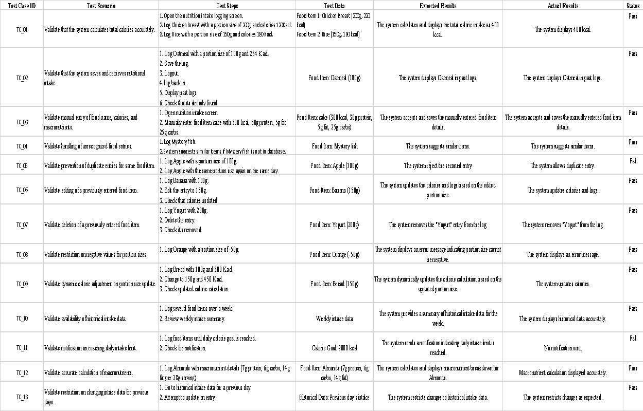

Use Case 4: View Progress

Description
- Use Case: View Progress
- Actors: User
- Type: Primary and Essential
- Description:
  - The user selects "View Progress" from the app menu.
  - The system retrieves activity data, including exercise logs, calorie intake, water intake, and progress toward goals.
  - The system displays a visual summary of the user’s progress, such as charts or visual indicators.
  - The user views metrics on calories burned, exercise minutes, daily water consumption, and health goal progress.
- Cross Ref: session booking , meal plan
- Preconditions: The user must be logged in and have some logged activity data.
- Postconditions: The system displays a visual representation of the user’s progress with real-time updates.
- Alternate Scenarios:
  - AF1: If insufficient data is available, the system encourages the user to log more activities.
  - AF2: If the user achieves a milestone, the system displays a congratulatory message.

Interaction Scenario

Actor Intention | System Responsibility
 | - The system retrieves and displays the user’s activity data, including exercise logs, calorie intake, and water intake.  4.The system displays a visual summary of progress, such as charts or indicators for calories, water, and goals  6. The system saves the user’s view preferences and returns to the main screen.
  1. The user opens the "View Progress" section.
  3. The user views detailed metrics for their health goals.
  5. The user closes or navigates away from "View Progress".

Test requirements:

5.1 Exercise Tracking
- 5.1.1 Validate that users can log their exercise details (e.g., duration, intensity, calories burned).
- 5.1.2 Validate that the system calculates and displays total calories burned after each workout session.
- 5.1.3 Validate that users can view a summary of their exercise history in the app.
5.2 Nutritional Intake Tracking
- 5.2.1 Validate that users can log their daily nutritional intake, including calories, proteins, fats, and carbohydrates.
- 5.2.2 Validate that the system calculates and displays total calorie consumption for the day.
- 5.2.3 Validate that users can view a history of their nutritional intake.
5.3 Water Consumption Tracking
- 5.3.1 Validate that users can log their daily water intake in the app.
- 5.3.2 Validate that the system displays the total water consumed by the user each day.
- 5.3.3 Validate that users can set a daily water intake goal and view progress toward that goal.
5.4 In-Body Measurements Tracking
- 5.4.1 Validate that users can log in-body measurements like weight, BMI, and body fat percentage.
- 5.4.2 Validate that the system calculates BMI based on user input and displays the result.
5.4.3 Validate that users can view historical data of their body measurements

Test cases
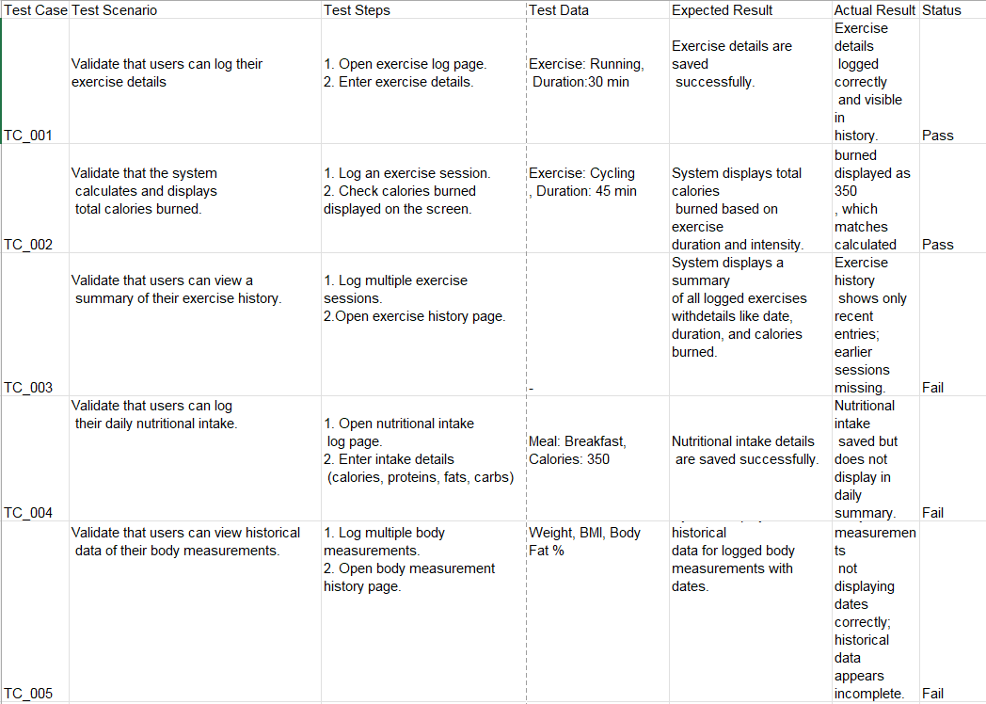

Use Case 6: Manage Premium Subscription

Description

Use Case: Manage Premium Subscription
- Actors: General User, Bank Repository System
- Type: essential and primary
- Description:
- Allows users to manage their premium subscription, including activation and cancellation options, users receive confirmation mails. The user initiates a subscription, and the system processes payment, confirms activation, and provides access to premium features.
- Cross Ref: Authenticated account
Payment gateway
Subscription features access
- Preconditions: The user must be logged into the account.
The user must have a valid payment method linked to their profile.
If modifying or canceling, the user has an active subscription.
- Postconditions: The user gains or retains access to premium features.
For modifications or cancellations, the user receives a confirmation email, and their account is updated accordingly.
- Alternate Scenarios:
The user wants to subscribe but does not add the card’s info --> the user cannot subscribe

Interaction Scenario
Actor Intention | System Responsibility
User opens the "Manage Premium Subscription" page. | System displays available subscription options.
System displays available subscription options. | System prompts for credit card payment information.
User clicks the "Subscribe" button. | System prompts for credit card payment information
User enters credit card details. | System verifies and securely processes the payment if the info is correct and send a confirmation mail.
User enters credit card details. | System verifies payment details. If incorrect, displays an error message prompting for correction.
User re-enters correct credit card details. | System re-verifies and securely processes the updated payment details, sends a confirmation email and gives the user access to the premium features.
User selects "Cancel Subscription." | System processes the cancellation, reverts the user to the free version, and sends a cancellation confirmation email.

Test requirements
1.validate that user can add his card info
2.validate that the system checks if the user’s card info is correct to proceed subscription payment
3.validate validate that the payment method happens if the info is correct
4.validate that the user cannot pay if the info is wrong
5.validate that the user can rewrite the card info if it is incorrect
6.validate that the user can click on subscribe to proceed the payment
7.validate that the user has access to premium features
8.validate that the user can choose his coach
9. validate that the user can choose his Dr
10.validate that user can schedule private meetings with his Dr
11.validate that the user can schedule private meetings with his coach
12.validate that the user can view the training plans assigned to him by his coach
13.validate that the user can choose cancel subscription button
14.validate that the user doesn’t have access to the premium features after he unsubscribe

Test cases
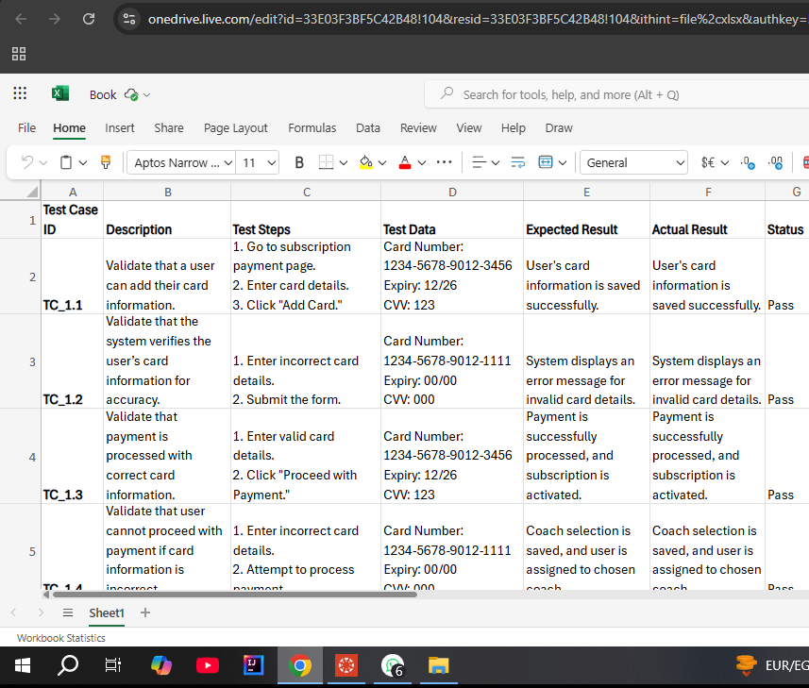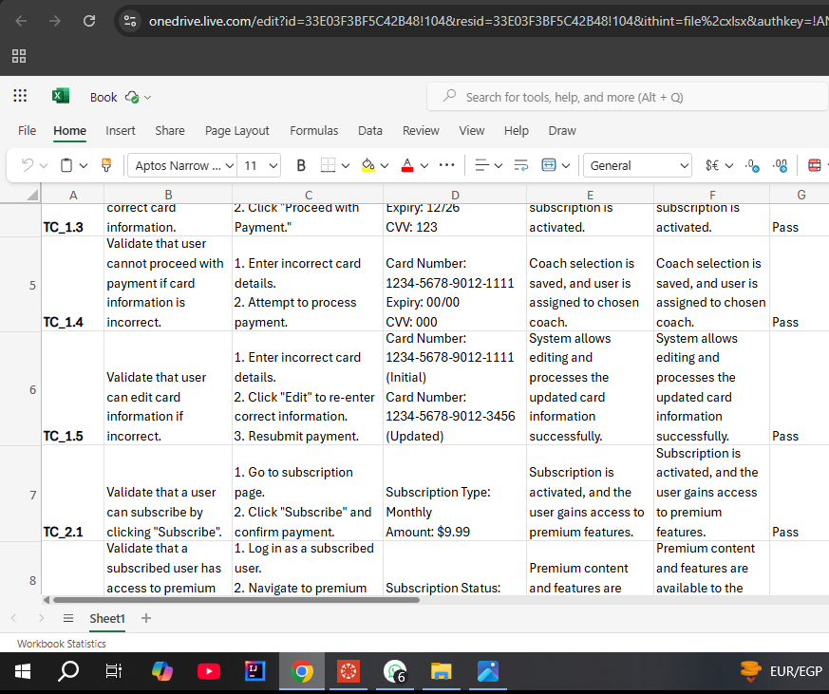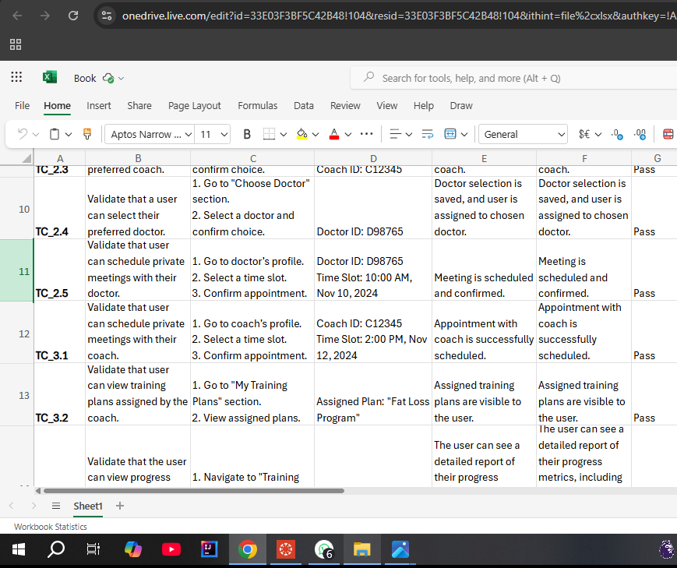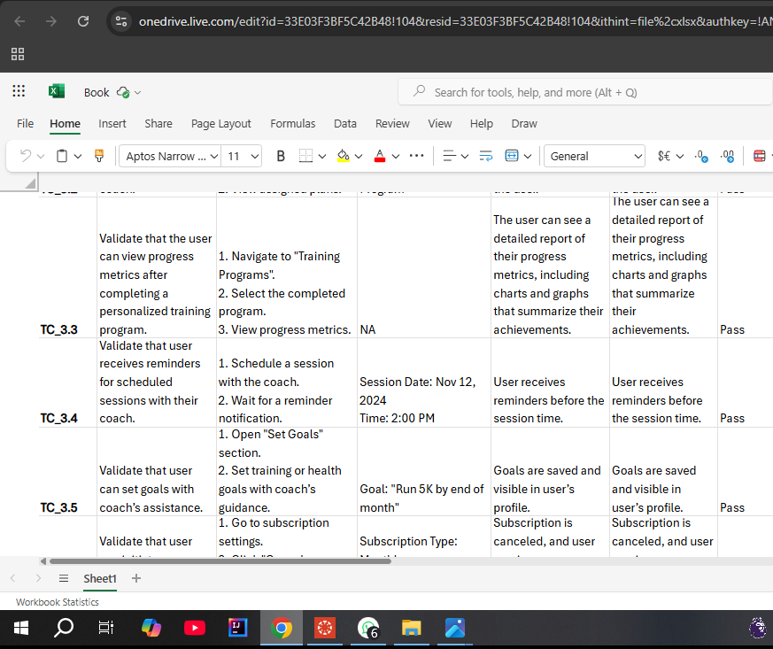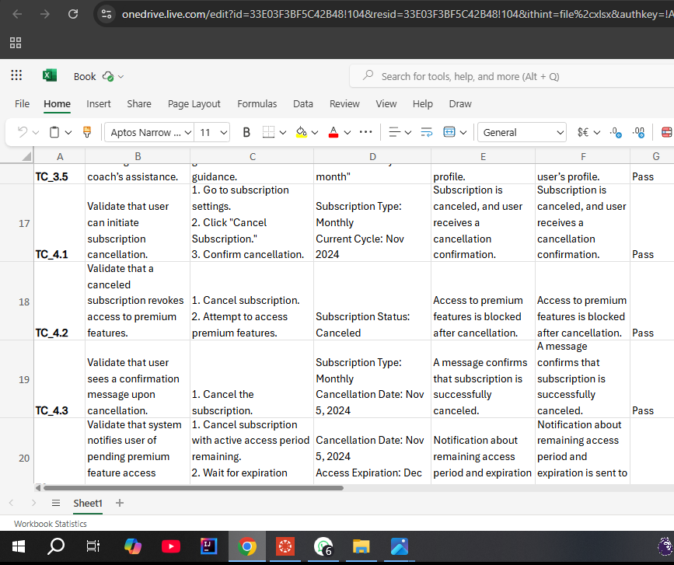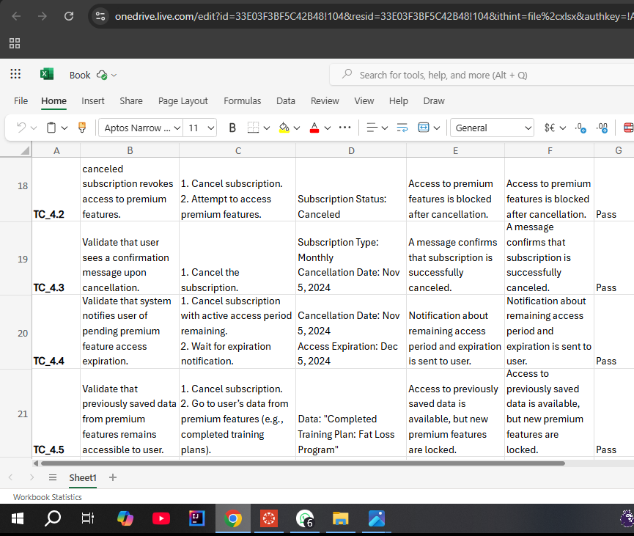
Link:
https://1drv.ms/x/s!AkgrxPU7P-AzaN2WUw_lYd9DaYE?e=m4yaTf

Use Case 7: Manage Session Booking

Description
- Use Case: Manage Session Booking
- Actors: Premium User
- Type: Primary and Essential
- Description:
  - The user selects "Book Session" to schedule a meeting with a coach or doctor.
  - The user selects a professional and available time slot.
  - The system verifies the time slot’s availability.
  - The system confirms the booking and sends notifications to both the user and the professional.
- Cross Ref: User registration, premium subscription
- Preconditions: The user must be a premium subscriber and logged in.
- Postconditions: The session booking is saved in the system, and notifications are sent.
- Alternate Scenarios:
  - Unavailable Time Slot: If the chosen time slot is unavailable, the system suggests alternative slots.

Interaction Scenario

Actor Intention | System Responsibility
- The user opens the "Session Booking".  - The user selects a coach or doctor and an available time slot.  - The user confirms the session booking | - The system displays a list of available professionals and times.  - The system verifies the availability of the selected time slot.  - The system confirms the booking and sends notifications to both the user and the professional.
Actor Intention | System Responsibility
- The user opens the "Session Booking".  - The user search for specific coach or doctor.  - The user selects a coach or doctor and an available time slot.  - The user confirms the session booking | - The system verifies the availability of the selected time slot.  - The system confirms the booking and sends notifications to both the user and the professional.
Actor Intention | System Responsibility
- The user opens the "Session Booking".  - The user filters for specific gender of coach or doctor or time.  - The user selects a coach or doctor and an available time slot.  - The user confirms the session booking | - The system verifies the availability of the selected time slot.  - The system confirms the booking and sends notifications to both the user and the professional.

Test requirements

- Validate that the system checks for availability and prevents double booking for the selected time slot.
- Validate that the system saves session booking details
- Validate that the system sends a confirmation notification to user after booking a session, including details such as date, time, and professional name.
- Validate that the system sends notifications to professional.
- Validate that the system suggests alternative time slots if the user’s selected time which is unavailable or previously.
- Validate that the system only allows premium users to access the session booking feature.
- Validate that the system allows the user to cancel a booked session.
- Validate that the system allows the user to reschedule a booked session.
- Validate that the system updates the calendar of the professional when a session is booked or rescheduled.
- Validate that the system prevents booking of different sessions by the same user for different professionals.
- Validate that the system automatically adjusts the available time slots when a session is canceled.
- Validate that the system restricts session bookings to future dates only, preventing the user from selecting a past date.
- Validate that the system handles situations when the professional cancels a session, by notifying the user and suggesting alternative professionals or times.
- Validate that the system allows users to filter available professionals by specialty, language, gender, time, rating.

Test cases

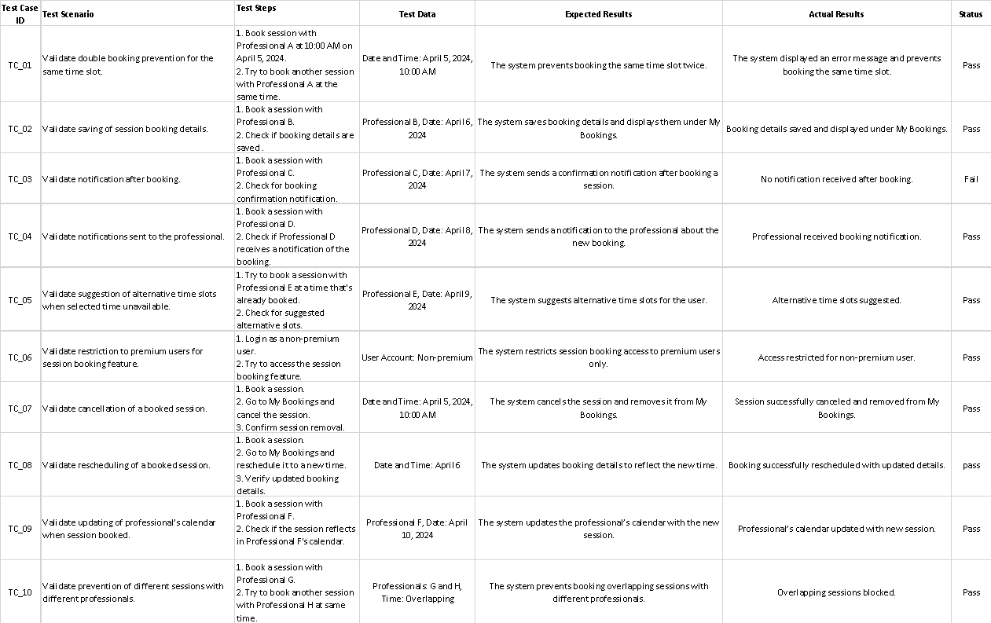

Use Case 8: Manage Notifications

Description
- Use Case: Manage Notifications
- Actors: User
- Type: primary and Essential
- Description:
  - The user customizes notification preferences (type and frequency).
  - The system updates the user’s notification settings.
  - Notifications are delivered to the user based on the new settings.
- Cross Ref: User registration, notifications Settings
- Preconditions: The user must be logged in.
- Postconditions: Updated notification preferences are saved and applied.
- Alternate Scenarios:
  - The user doesn’t make changes and click save: the system doesn’t allow the user to save or exit until recustomize the settings to click cancel.

Interaction Scenario

Actor Intention | System Responsibility
- The user opens notification settings.  - The user selects preferred notification settings. | - The system displays options for notification type and frequency.  - The system saves settings and adjusts notifications accordingly.

Test requirements

- Validate that the system allows the user to update notification preferences and saves the settings.
- Validate that the system sends notifications according to the updated user preferences.
- Validate that the system allows the user to enable or disable specific notification types.
- Validate that the system doesn’t send notifications when the user has enabled "Do Not Disturb" mode.
- Validate that the system supports different notification channels as (email, SMS, in-app) based on user preference.
- Validate that the system provides users with a notification history to review past notifications.
- Validate that the system stops sending notifications immediately if the user disables them.
- Validate that the system adapts reminders based on the user’s time zone and preferred reminders times.

Test cases

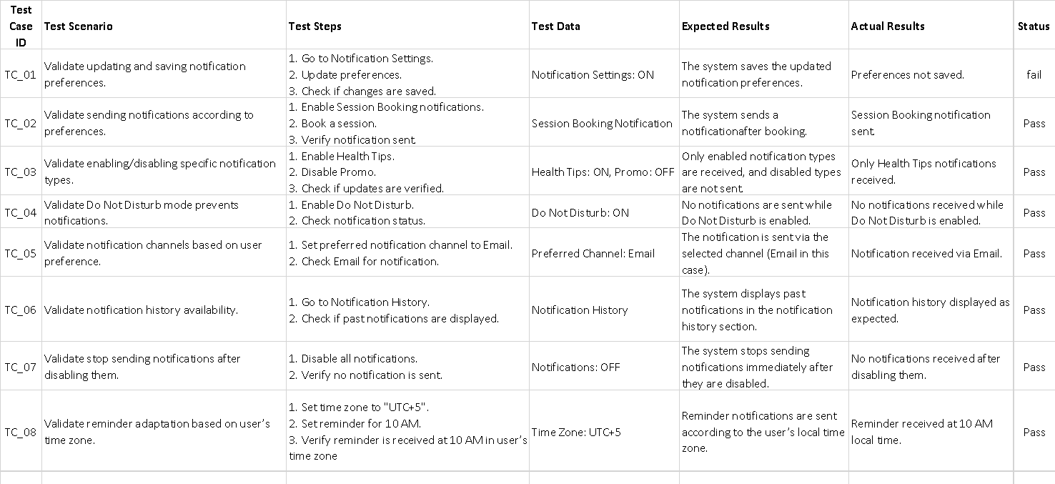

Use Case 9: manage doctor’s subscribers

Test requirements

1. validate that the doctors can view the users assigned to him
2. validate that the doctors can upload content
3. validate that doctors can upload meal plans for users according to their conditions
4.validate that the Dr can view users’ info
5. validate that the Dr can view users’ progress
6. validate that the Dr can view users’ goals
7.validate that the Dr can open private pre-scheduled meetings with users

Test cases
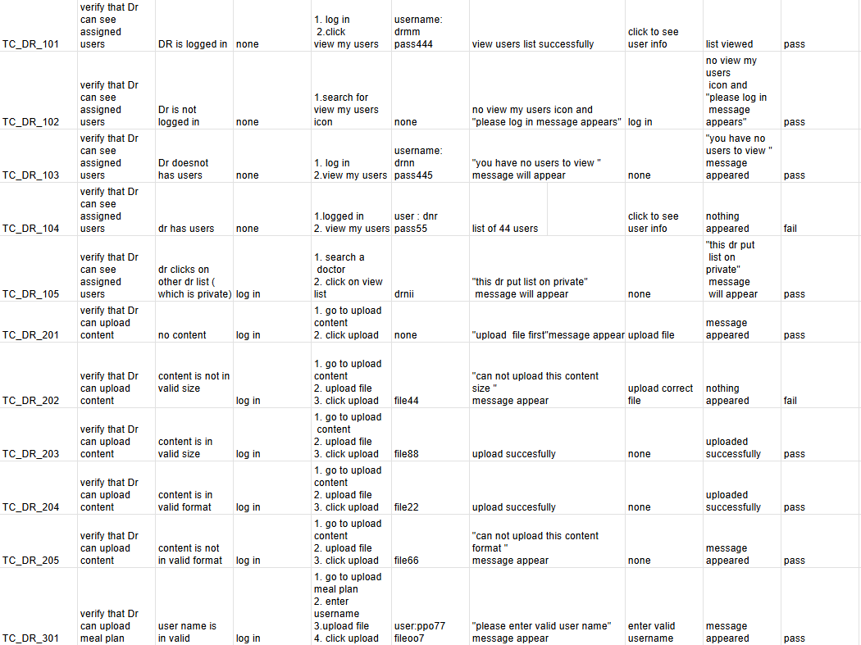
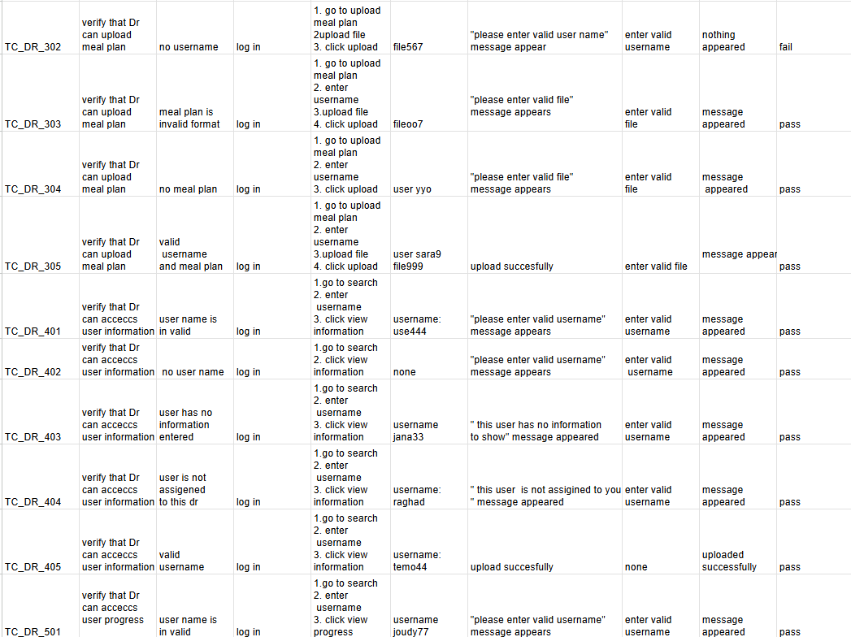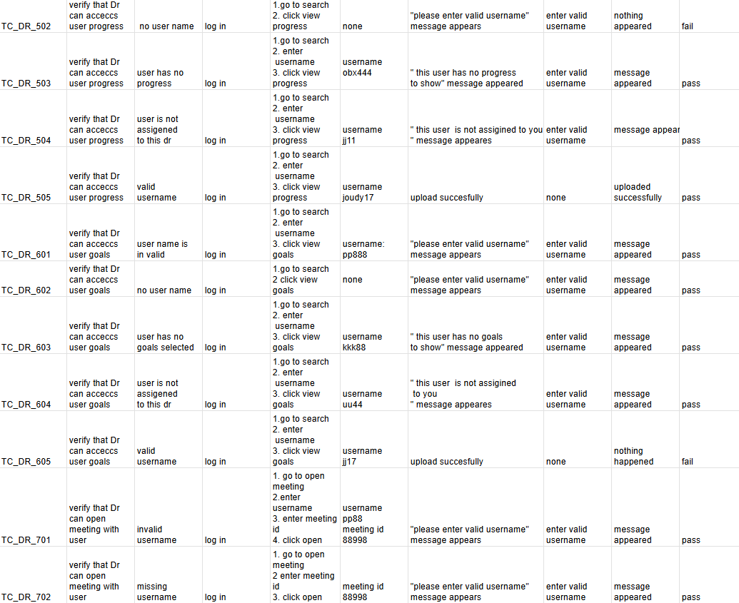
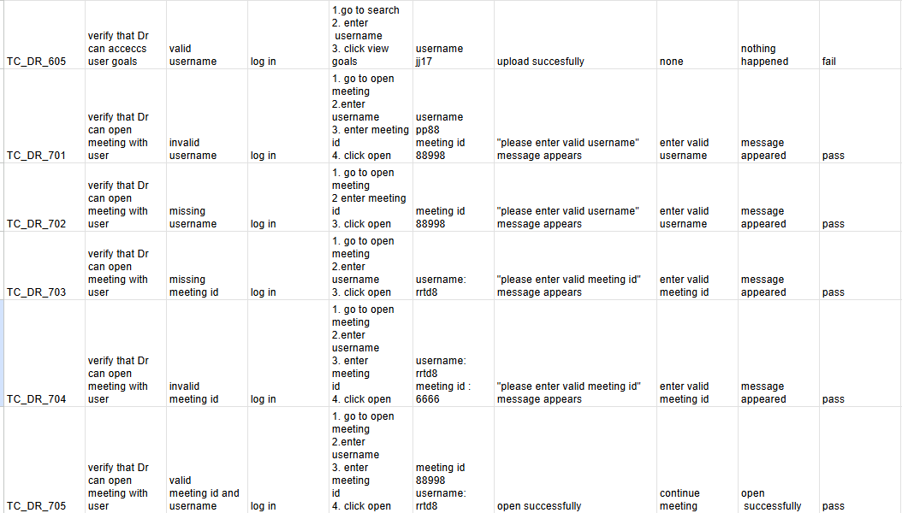
link DOCTOR
https://docs.google.com/spreadsheets/d/1fcpOFbRSWQHvI5uf5aEUzwqmnyEBx6BDe77EhAQ-uA4/edit?usp=sharing

Use Case 10: manage coach’s subscribers

Test requirements

1. validate that the coaches can view the users assigned to them
2. validate that the coaches can upload content
3. validate that coaches can upload training plans for users according to their conditions
4.validate that the coach can view users’ info
5. validate that the coach can view users’ progress
6. validate that the coach can view users’ goals
7.validate that the coach can open private pre-scheduled meetings with users

Test cases
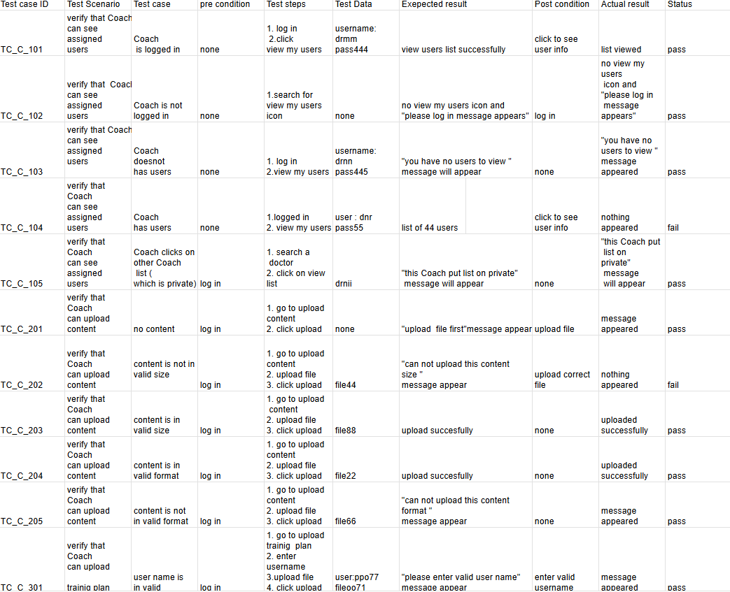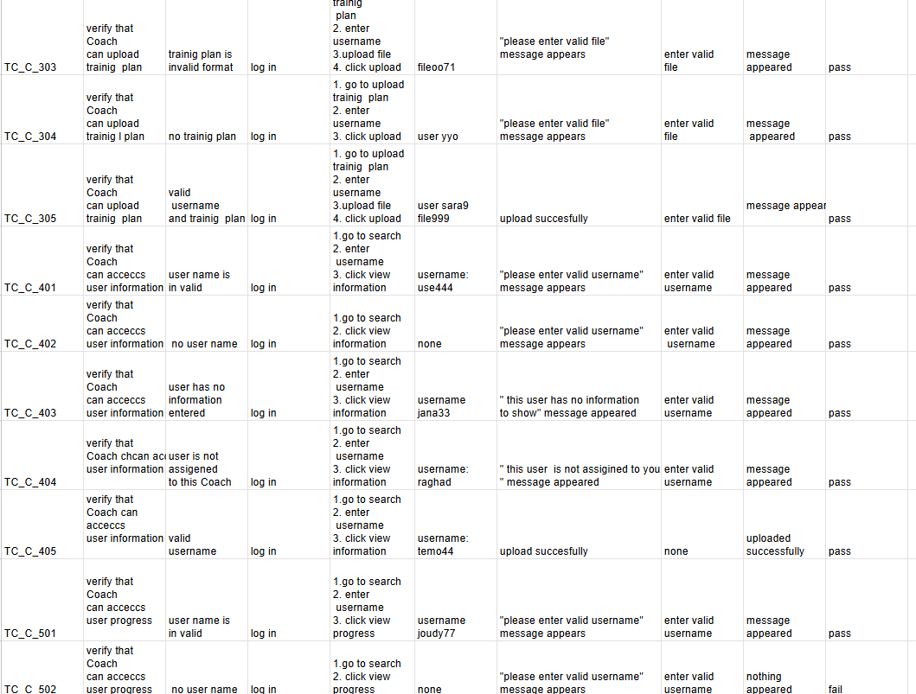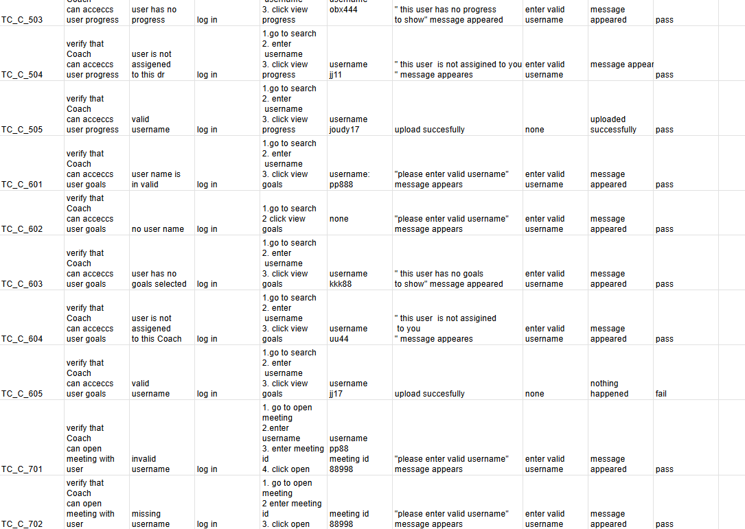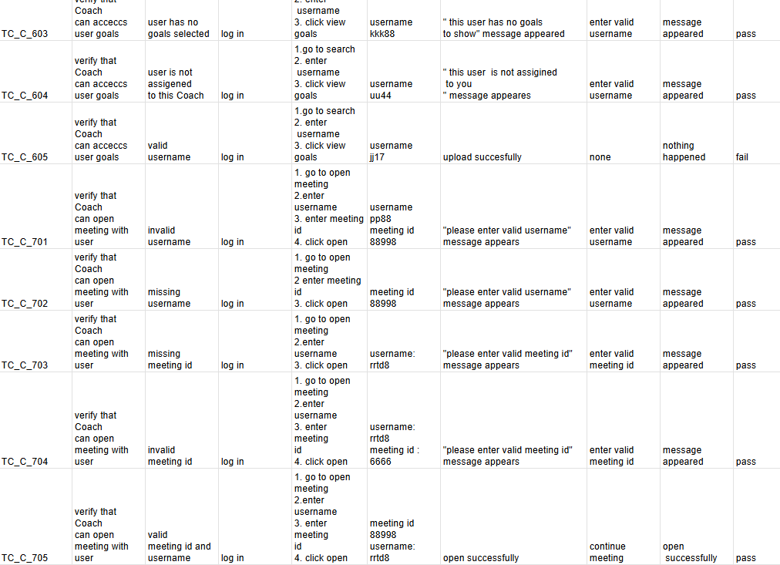
link coach
https://docs.google.com/spreadsheets/d/110Wm_kVyMcDt4U5Vq9h9boxUKpQUnyAktM1cuYWTn2M/edit?usp=sharing

Use Case 11: Manage Meal Plans

Description
- Use Case: Manage Meal Plans
- Actors: User, doctor
- Type: Primary and Essential
- Description:
  - The user navigates to "Manage Meal Plans" from the app menu.
  - The system retrieves meal suggestions based on the user’s dietary preferences and health goals.
  - The user customizes the meal plan by replacing items, adjusting portion sizes, or adding new meals.
  - If the user has premium subscription the doctor do it for hem
  - The system updates nutritional information according to the user’s customizations.
- Cross Ref: view progress , mange nutrition intake, doctor subscribtion
- Preconditions:
  - The user must be logged in and have set dietary preferences or health goals.
  - The user must have premium subscription if he want specific plan
- Postconditions: The customized meal plan is saved, and updated nutritional information is available for daily reference.
- Alternate Scenarios:
AF1: If dietary preferences are not set, the system prompts the user to configure them for personalized meal suggestions.
AF2: If a meal replacement is unavailable, the system suggests similar items as alternatives.

Interaction Scenario

Actor Intention | System Responsibility
1. The user opens the "Manage Meal Plans" section  - The user selects or customizes meal options.  5. The user saves the customized meal plan. | 2. The system retrieves and displays meal suggestions based on the user’s dietary preferences and health goals.  - The system updates nutritional information based on the customizations made by the user.  6. The system saves the meal plan and updates it for daily or future reference.

Test requirements:

11.1 Meal Suggestions:
- 11.1.1 Validate that the system suggests meals based on users' nutrition preferences and health goals.
- 11.1.2 Validate that users can view nutritional information (calories, proteins, fats, carbs) for each suggested meal.
- 11.1.3 Validate that users can view a list of meal options for each day.
11.2 Customization of Meal Plans:
- 11.2.1 Validate that users can replace suggested meal items with alternatives.
- 11.2.2 Validate that the system updates the nutritional information when a meal is customized.
- 11.2.3 Validate that users can save their customized meal plans.
11.3 Meal Logging:
- 11.3.1 Validate that users can log consumed meals and update daily calorie intake.
- 11.3.2 Validate that the system displays total daily calorie intake based on logged meals.
- 11.3.3 Validate that users can view a history of their logged meals.

Test cases

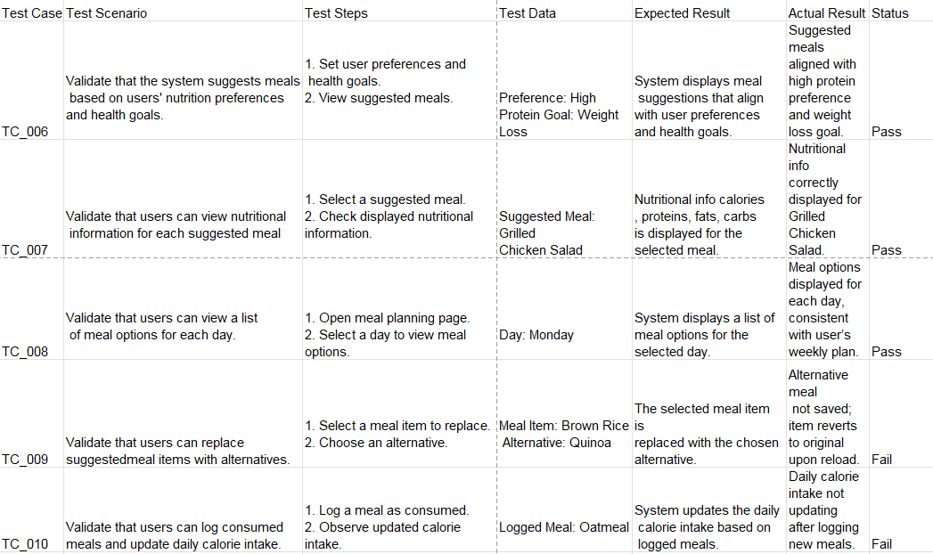

Use Case 12: Manage Reviews

Description
- Use Case: Manage Reviews
- Actors: User, Admin

- Type: Primary and Essential
- Description:
  - The user accesses "Manage Reviews" from the app menu.
  - The system displays any reviews the user has left, organized by feature or content reviewed.
  - The user writes a new review, edits an existing review, or deletes a review.
  - The system saves the review and updates the overall feedback rating for the reviewed feature or content.
  - The user can browse reviews left by other users.
- Cross Ref: mange session booking , manage coach subscribers, mange doctor subscribers, view prograss
- Preconditions: The user must be logged in and have used app features or consumed content
- Postconditions: The user’s review is saved and visible to others, contributing to feedback scores for specific features or content.

- Alternate Scenarios:
AF1: If the review contains prohibited content, the system prompts the user to edit the review.
AF2: If no reviews exist for a specific feature, the system encourages the user to leave the first review.

Interaction Scenario

Actor Intention | System Responsibility
 | - The system displays all reviews previously submitted by the user, organized by content type  4.The system provides a review interface for submitting or editing feedback, with prohibited language alerts if necessary  6. The system saves the review and updates the overall rating for the reviewed content.  8. The system displays reviews by others, ordered by date or rating, with an option to filter by topic.
  1. The user opens the "Manage Reviews" section | .
  3. The user selects a feature to review or edits an existing review.
  5. The user submits the review.
  7. The user views reviews from other users.

Test requirements

12.1 Real-Time Feedback
- 12.1.1 Validate that users receive real-time feedback on calorie intake, workout performance, and health stats.
- 12.1.2 Validate that the system provides suggestions to improve users' nutrition, exercise, or mindfulness routines.
- 12.1.3 Validate that feedback is updated dynamically based on user activities.
12.2 Health Goal Feedback
- 12.2.1 Validate that users receive progress updates toward their health goals (e.g., weight loss, muscle gain).
- 12.2.2 Validate that the system displays visual progress indicators, such as charts or progress bars.
- 12.2.3 Validate that users receive motivational messages when reaching key milestones.

Test cases
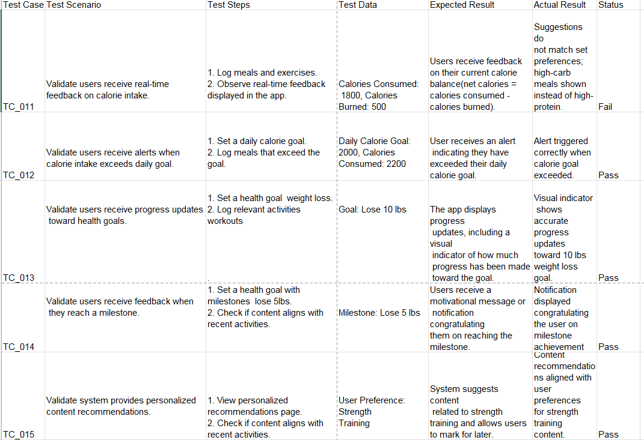

Use case description

Use case :
Manage content
Type :
Primary and essential
Actors:
User (initiator ), system
Description:
When user goes to home page the system views the recommended(according to user preferences ) available sessions ,doctors and coaches
With some details about them
Cross ref: Requirements:
User has an account and is logged in
Pre conditions:
User has logged in
User has entered his personal information and preferences
Post conditions:
User can book a session or an appointment with doctor or coach
Alternative scenarios:
User can go direct to his booked sessions and appointments or to search a specific one

Interactions :

Actor interaction: | System responsibility :
1. User logs in  2. User goes to home page  6. User can click on any session , doctor or appointment  9. User can see all details  10. User can book the appointemnt | 3. System takes user preferences  4. System shows available sessions according to user preferences with a preview about them  5. System shows available doctors and coaches with some information about them  7. System shows all details about clicked item  8. System shows a booking button

Test requirements :
- Validate that user is authenticated
- Validate that user has entered personal preferences
- Validate that all displayed sessions are still available
- Validate that all displayed sessions match user preferences
- Validate showing only available doctors
- Validate showing only available coaches

TEST CASES 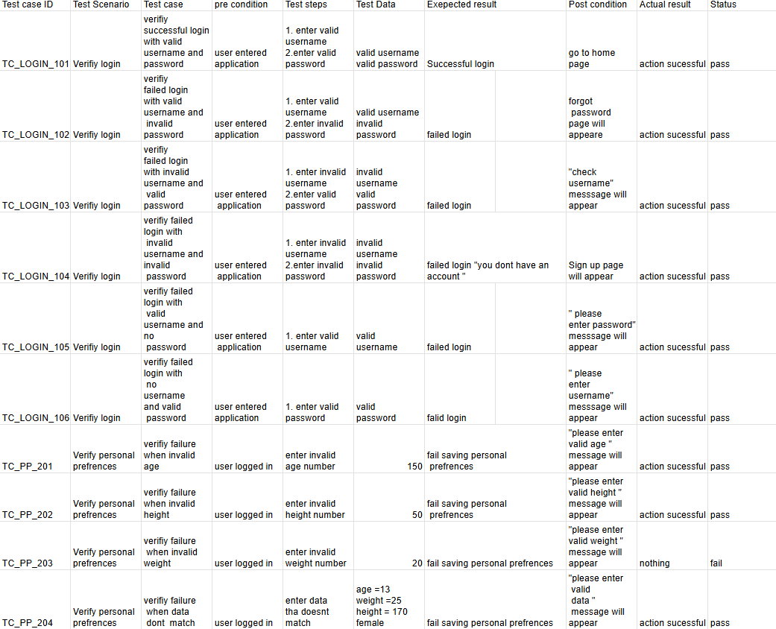
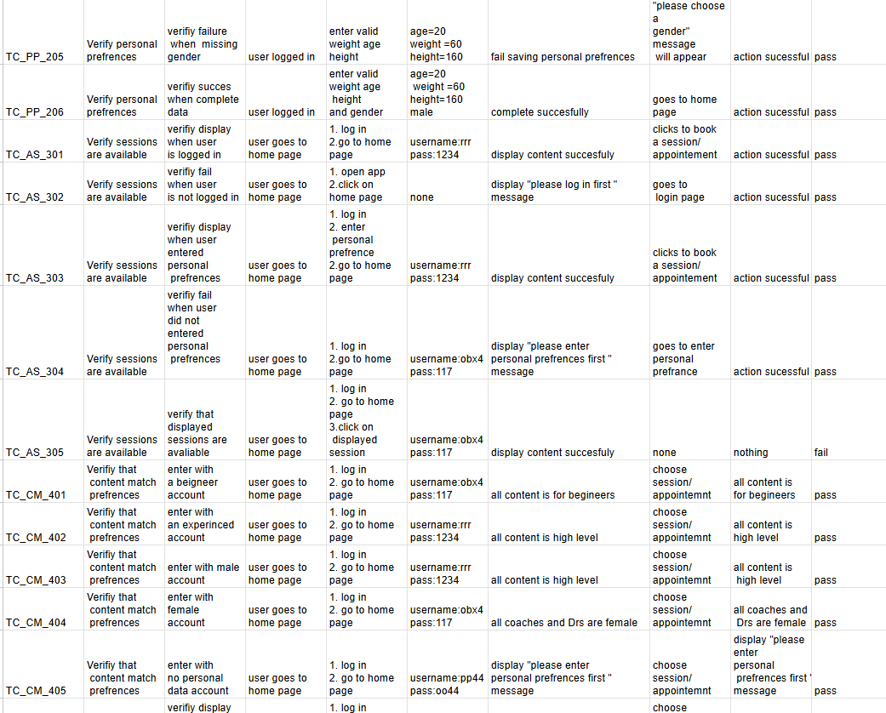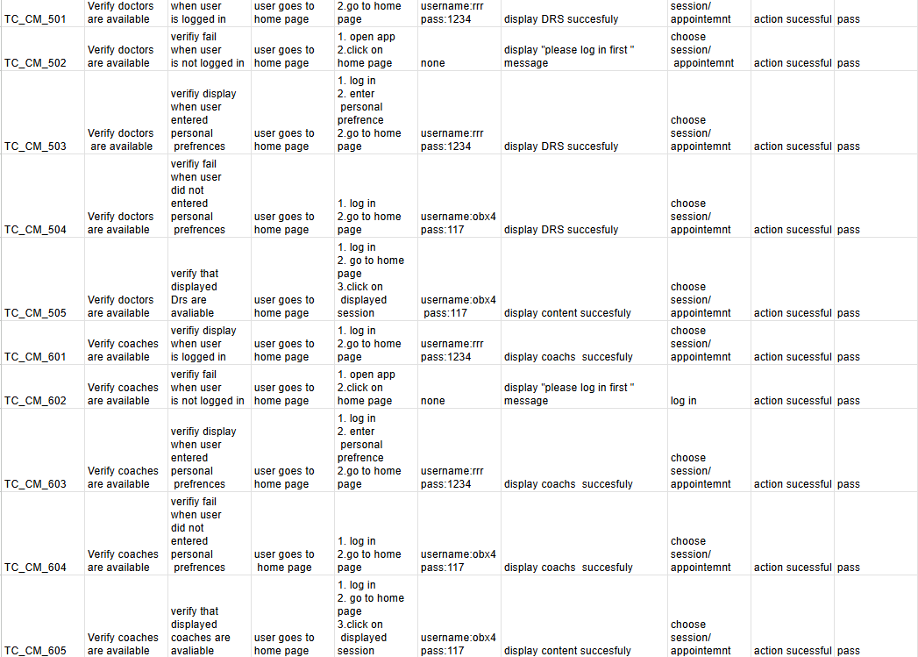
link https://docs.google.com/spreadsheets/d/1RrKyXwgJK09FnNe4cih2KgR0T5BQzVUXAh_9EqBoQ_c/edit?usp=sharing

Milestone 3
- ERD

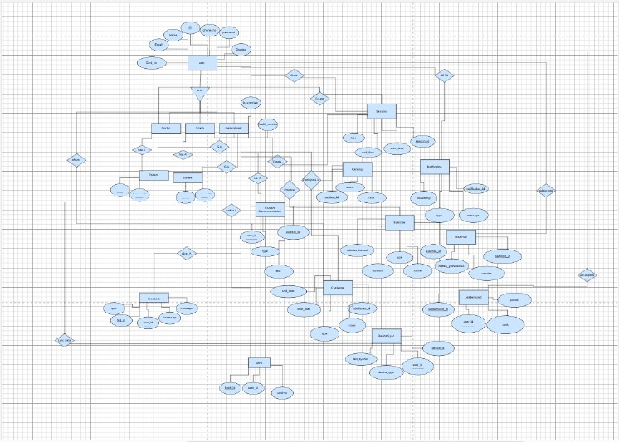

- Architecture levels

- Level 0

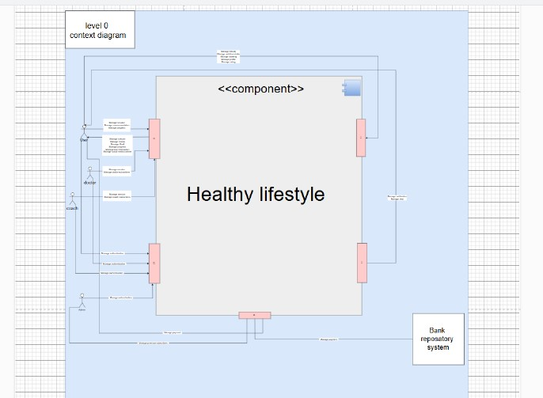

- Level 1
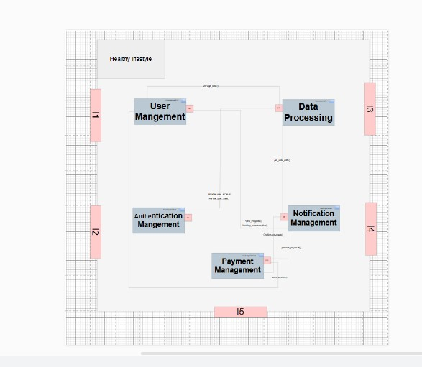

- Level 2

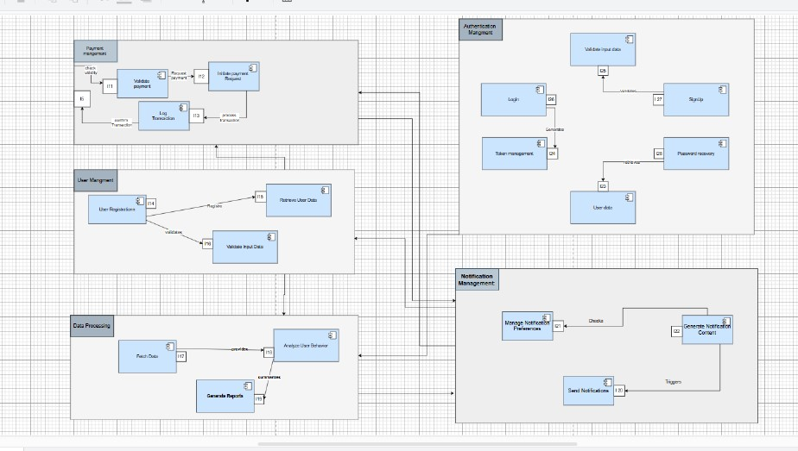

- Interfaces description

- Level 0

1. User Interface (UI)
Represents all user-facing interactions, such as input forms, dashboards, and reports.

Use Cases:
Manage sessions
Manage reviews
Manage recommendations
Manage goal
Manage progress
Manage user interaction
Manage social media content
Manage doctor subscribers
Manage coach subscribers

2. Authentication Service
Handles user authentication, login, and role-based access control.

Use Cases:
Manage authentication

3. Data Management Service
Manages storage, retrieval, and processing of data across various modules.

Use Cases:
Manage inbody (health/body composition data)
Manage nutrition intake
Manage booking
Manage profile
Manage rating

4. Notification System
Responsible for sending alerts, updates, and communication to users.

Use Cases:
Manage notification
Manage chat

5. Subscription & Payment Service
Handles payments, subscriptions, and financial transactions.

Use Cases:
Manage payment
Manage premium subscribers

- Level 1

1. User Management
Description: Manages user interactions such as registration, profile updates, and user roles.
Use Cases:
Register User
Manage User Profile
Validate User Credentials
Retrieve User Data

2. Authentication Management
Description: Handles user authentication, login, logout, and token management.
Use Cases:
Manage Authentication
Login User
Logout User
Reset Password

3. Data Processing
Description: Processes, stores, and retrieves data for analysis and decision-making.
Use Cases:
Manage Inbody Data (Health/Body Composition)
Manage Nutrition Intake
Manage Booking
Manage User Profile
Manage Ratings

4. Notification Management
Description: Sends alerts, notifications, and communication updates to users.
Use Cases:
Manage Notifications
Manage Chat
Send Alerts
Retrieve Notification History

5. Payment Management
Description: Handles payments, subscriptions, and financial transactions.
Use Cases:
Process Payments
Manage Premium Subscribers
Log Transactions
View Subscription Details

- Leve 2

1. User Interface (UI)
Decomposed Use Cases:
Input User Data
Display Reports
Manage User Dashboard
Update User Preferences
Track Social Media Activity

2. Authentication Service
Decomposed Use Cases:
Validate User Credentials
Generate Authentication Token
Reset User Password

3. Data Management Service
Decomposed Use Cases:
Store Inbody Data
Retrieve Nutrition Logs
Process Booking Requests
Update User Profile
Analyze Ratings

4. Notification System
Decomposed Use Cases:
Send Email Alerts
Push Mobile Notifications
Monitor Chat Logs
Schedule Notifications

5. Payment Service
Decomposed Use Cases:
Process Payment Transactions
Activate Premium Features
Cancel Subscription
Retrieve Payment History

- Class diagram

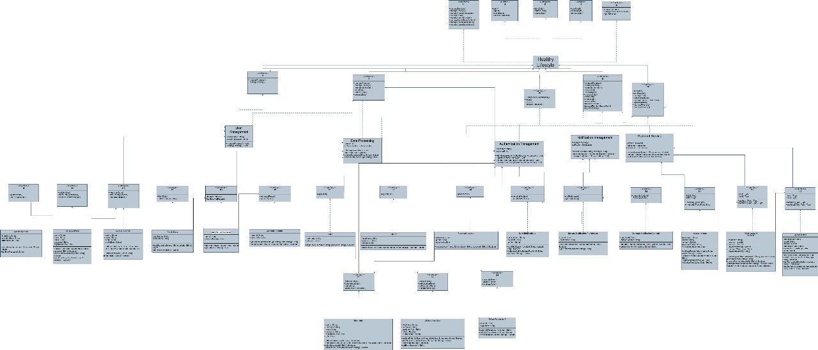

- Traceability matrix

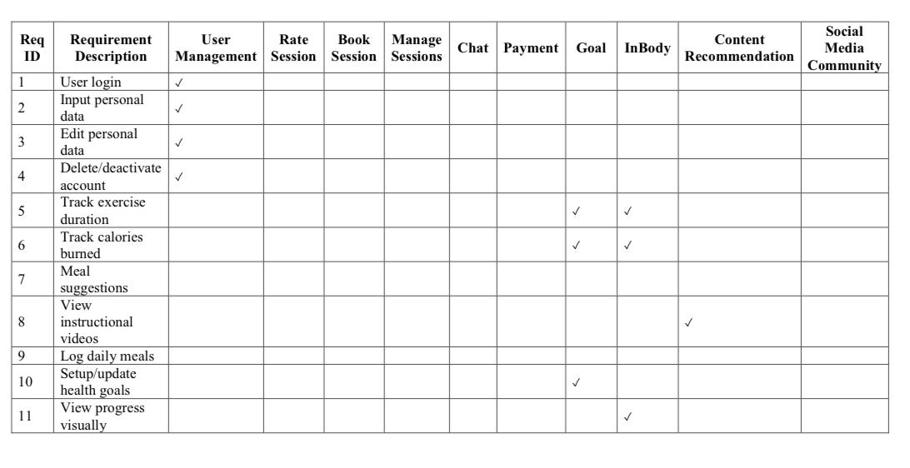

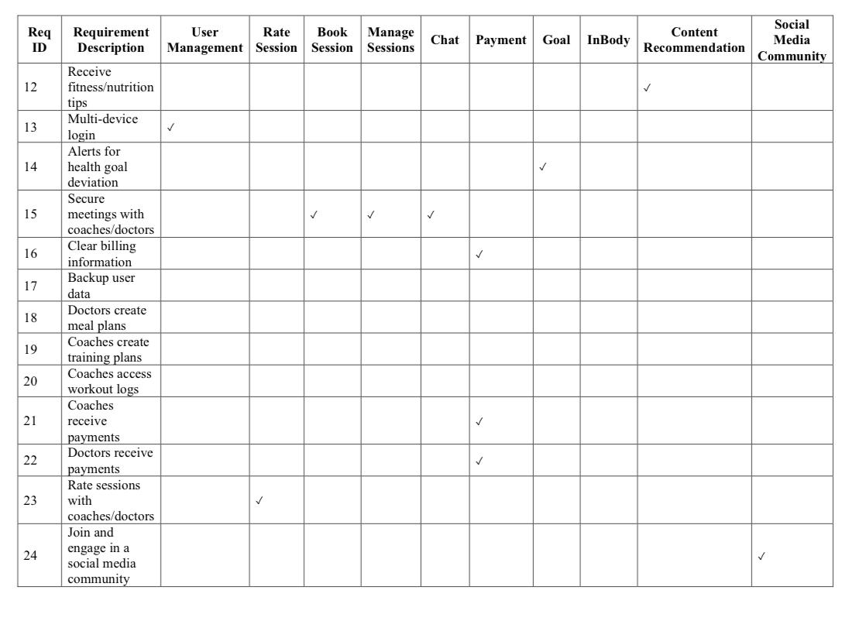

- Sequence diagrams

- Manage session

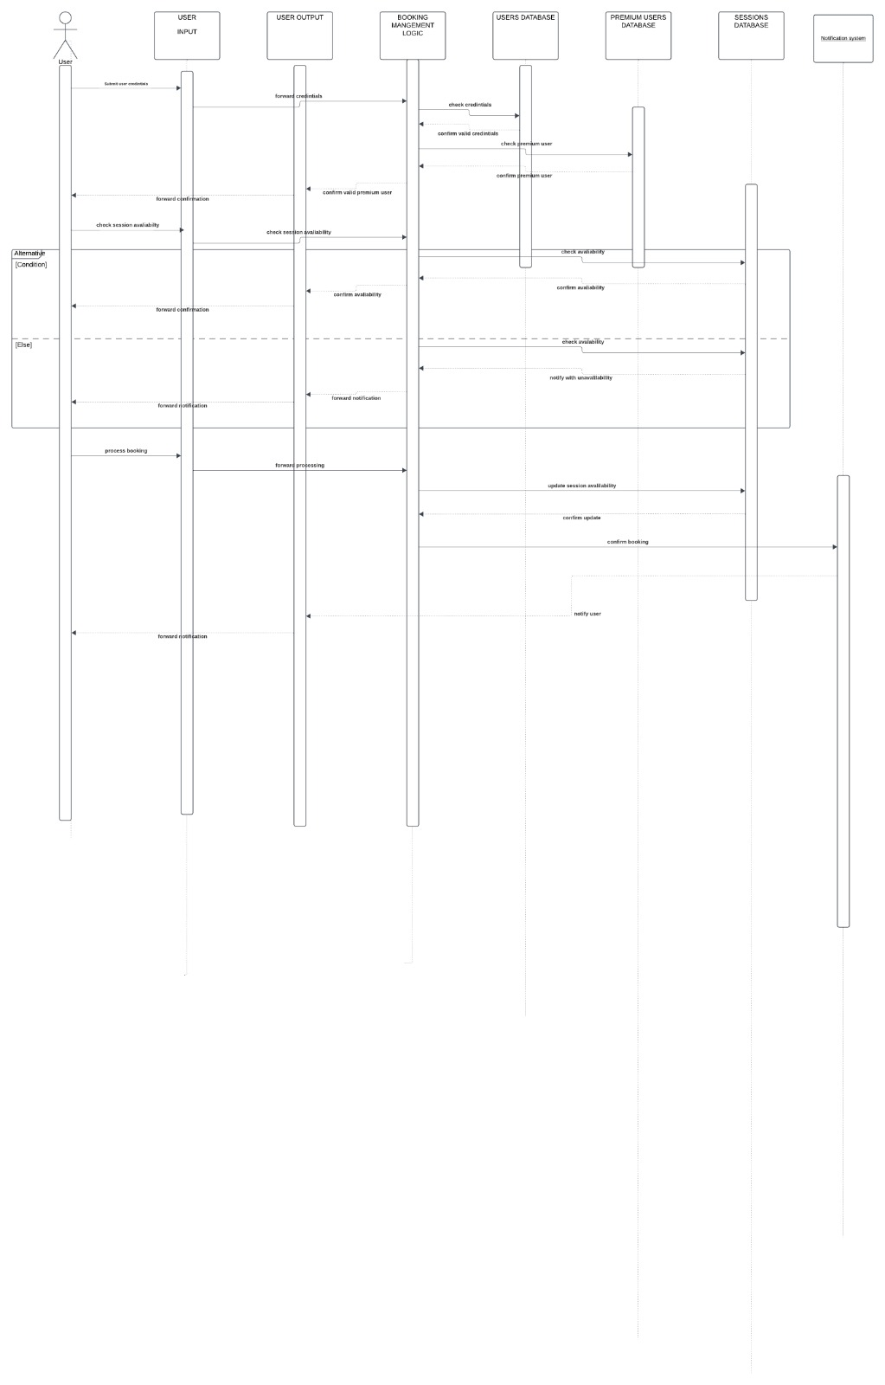

- Manage nutrition intake

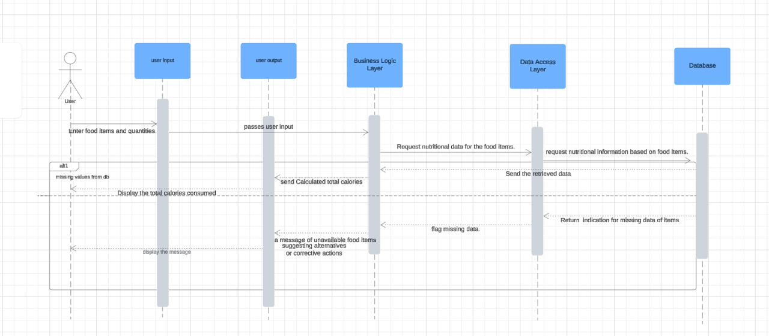

- Manage payment

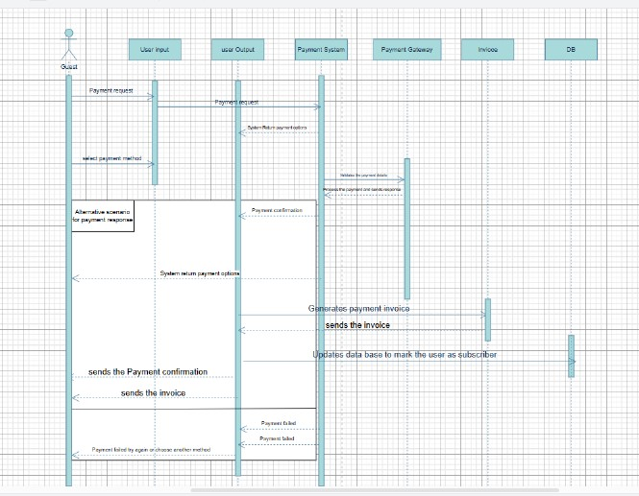

- Manage goal

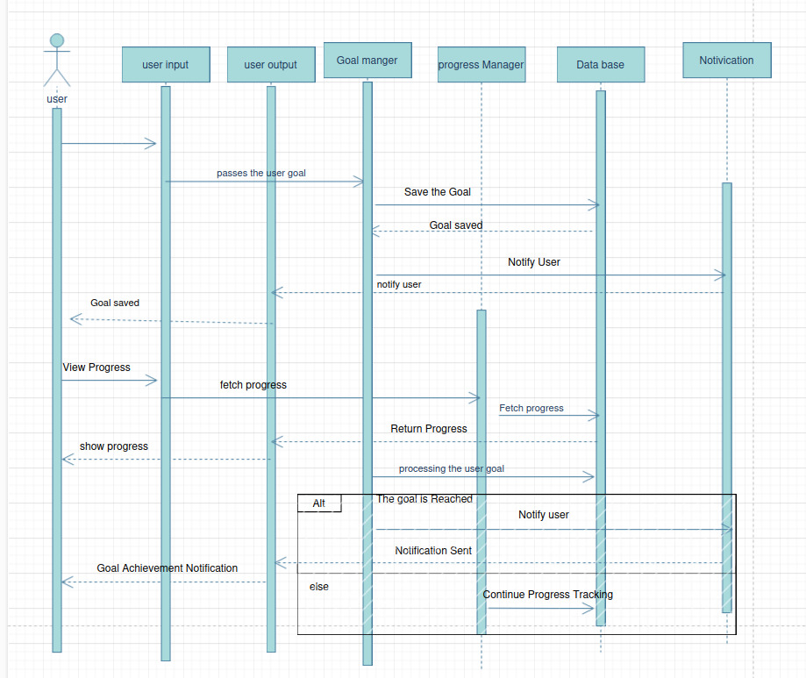

- Manage premium subscribers

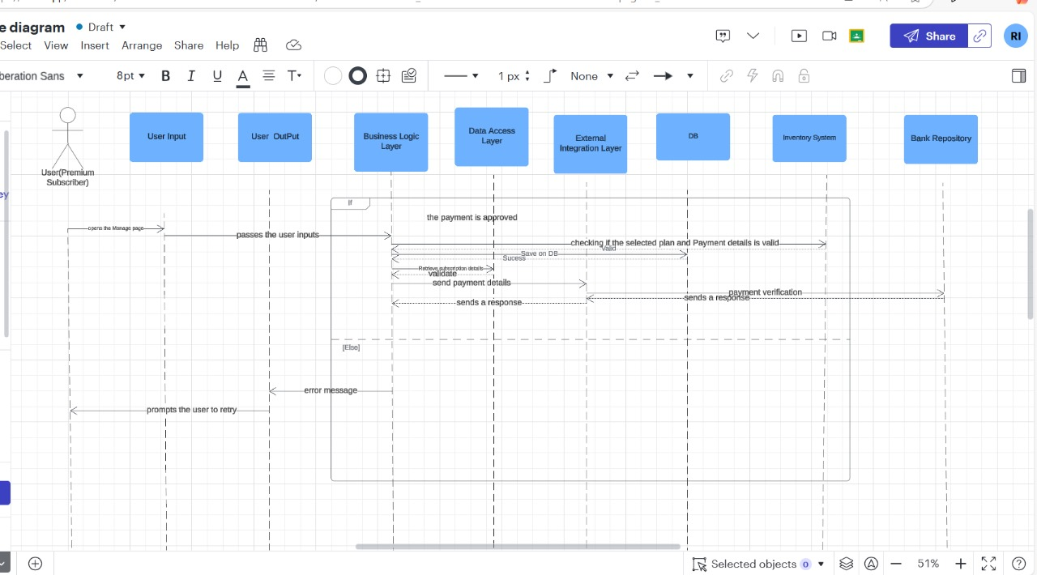

- Dataflow

- Level 0

- Manage session

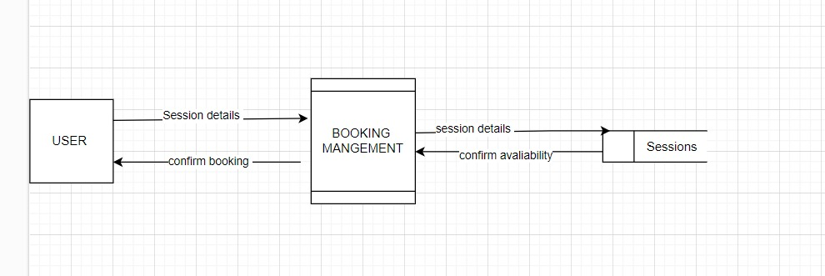

- Manage nutrition intake

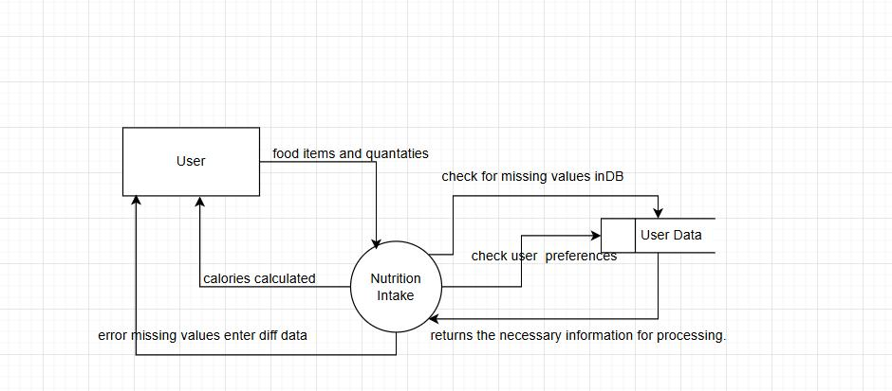

- Manage payment

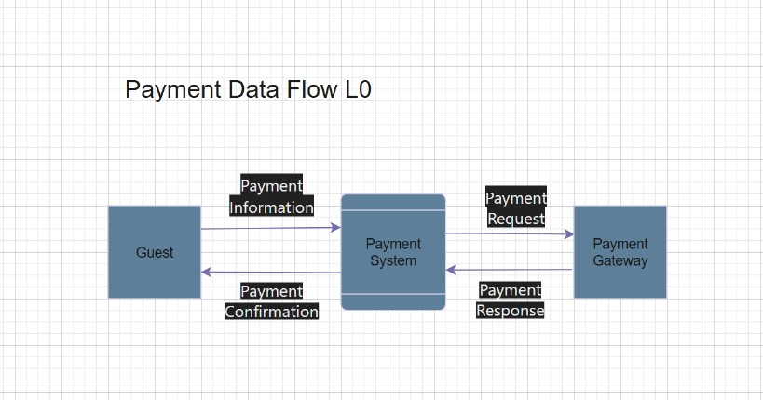

- Manage goal

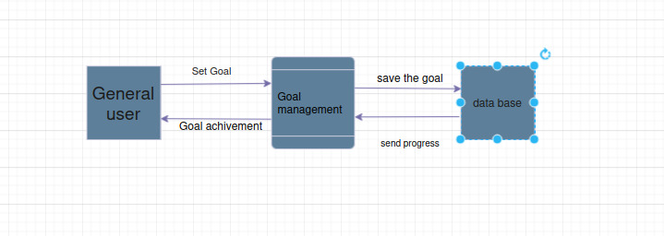

- Manage premium subscribers

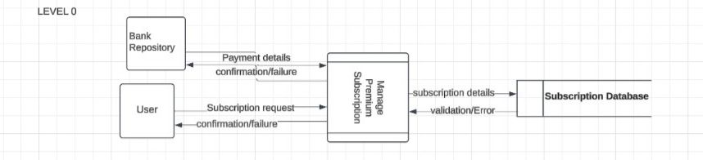

- Level 1

- Manage session

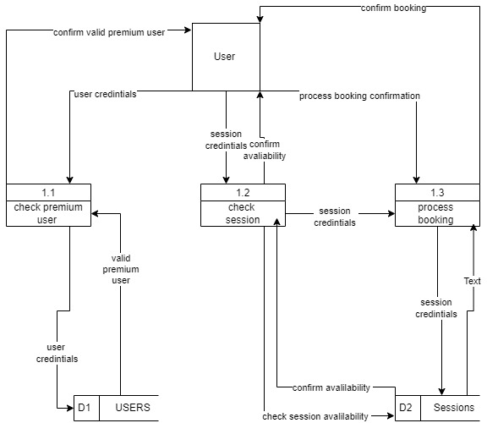

- Manage nutrition intake

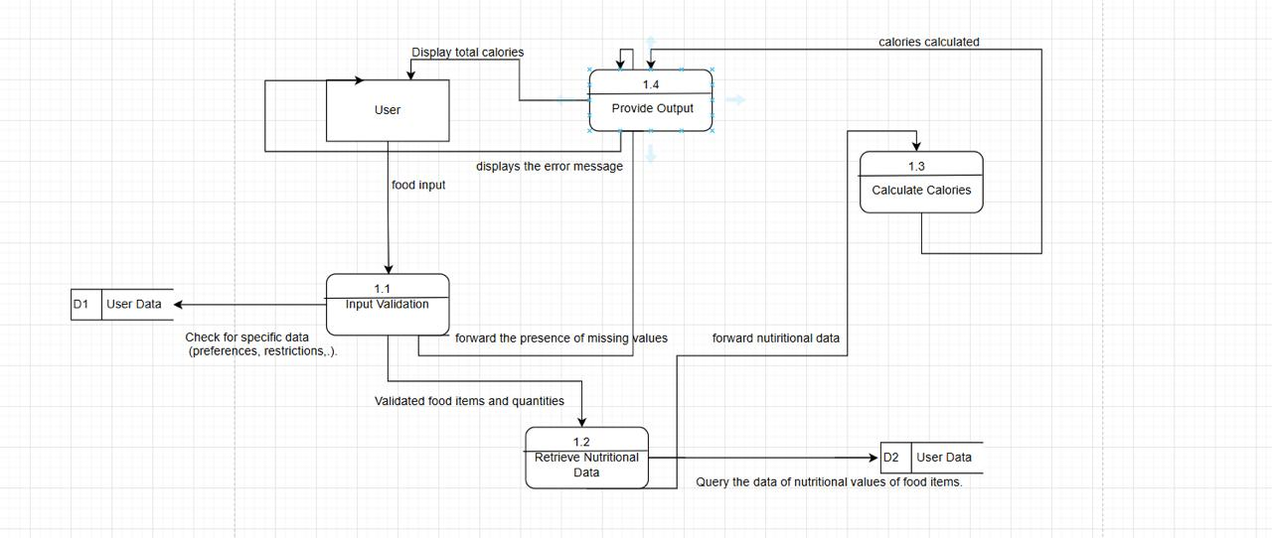

- Manage payment

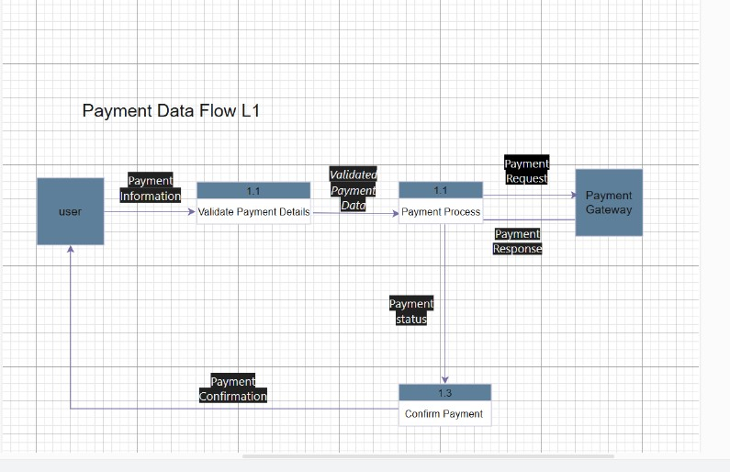

- Manage goal

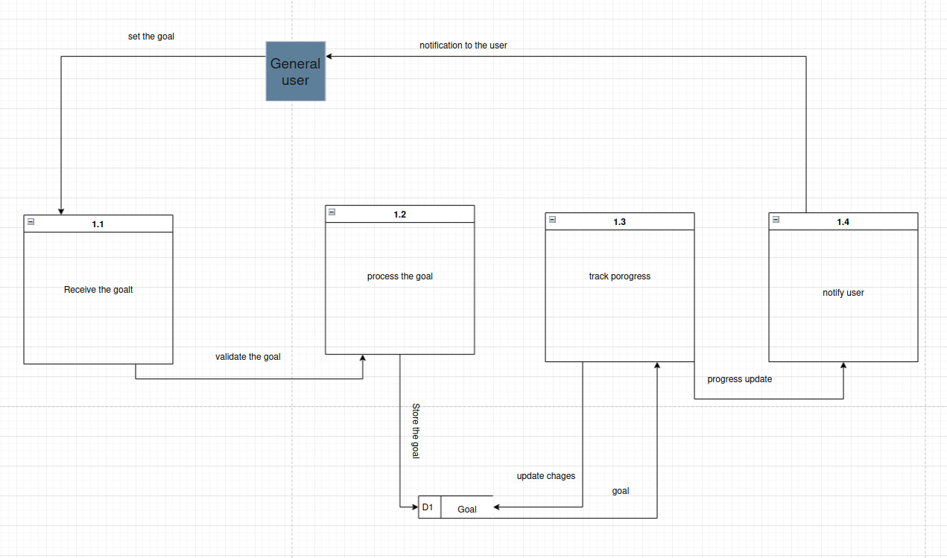

- Manage premium subscribers

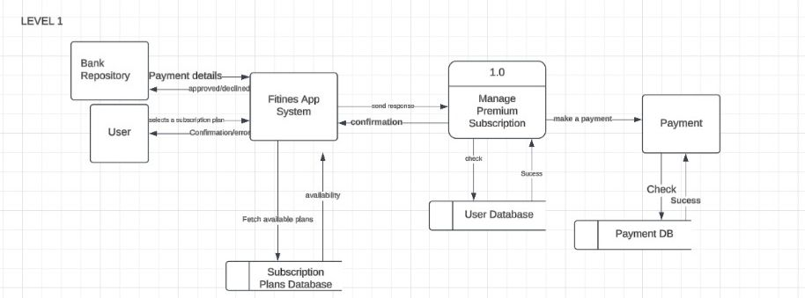

- Level 2

- Manage session

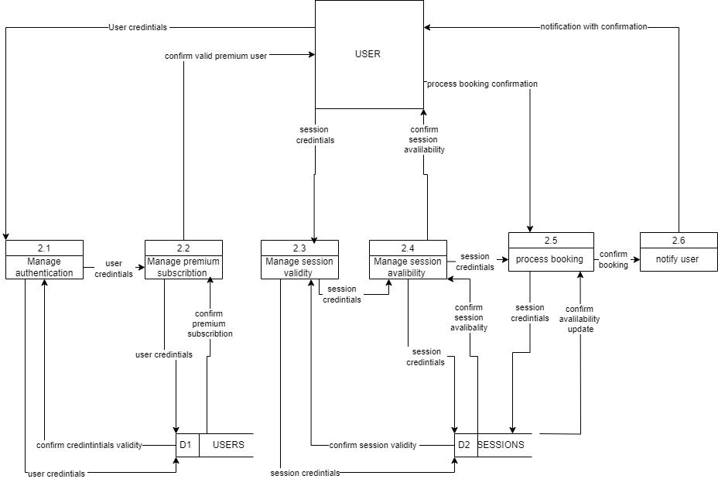

- Manage payment

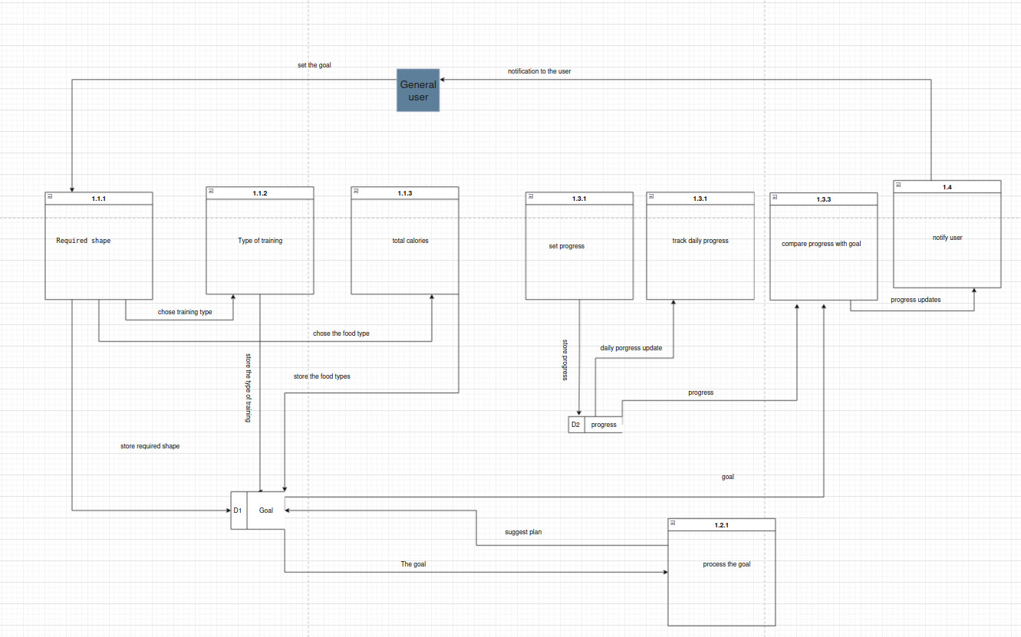

- Manage goal

- Use case estimation using Fibonacci method and corresponding Gantt chart

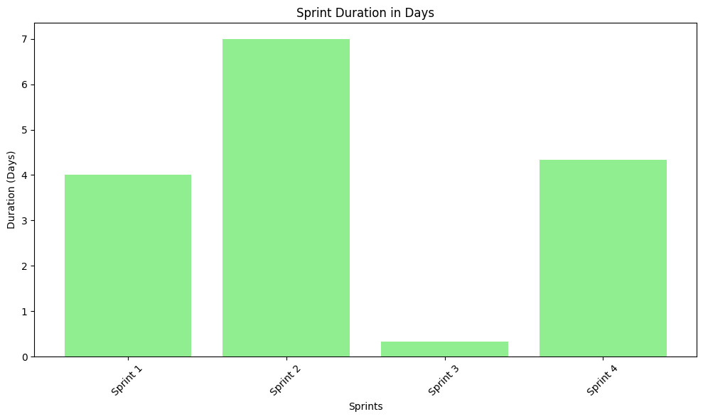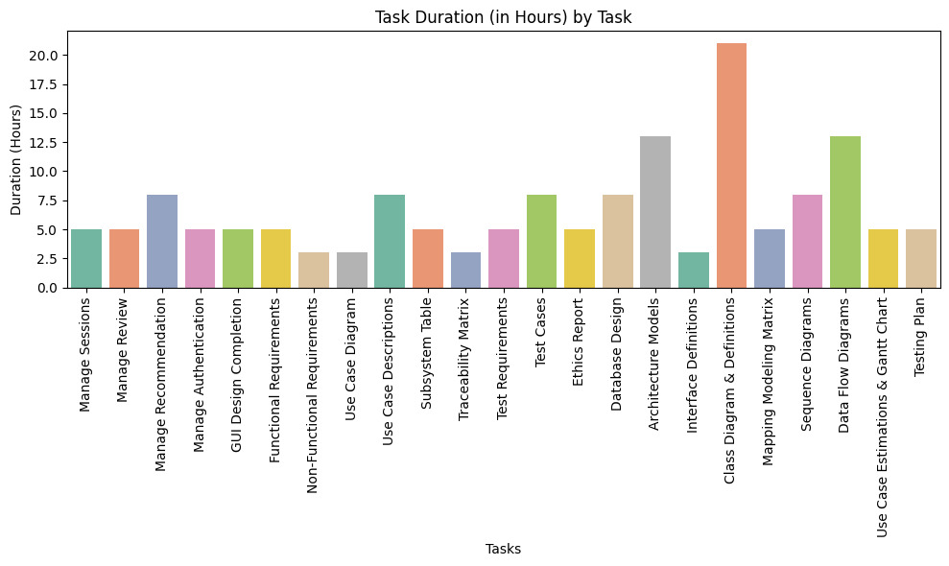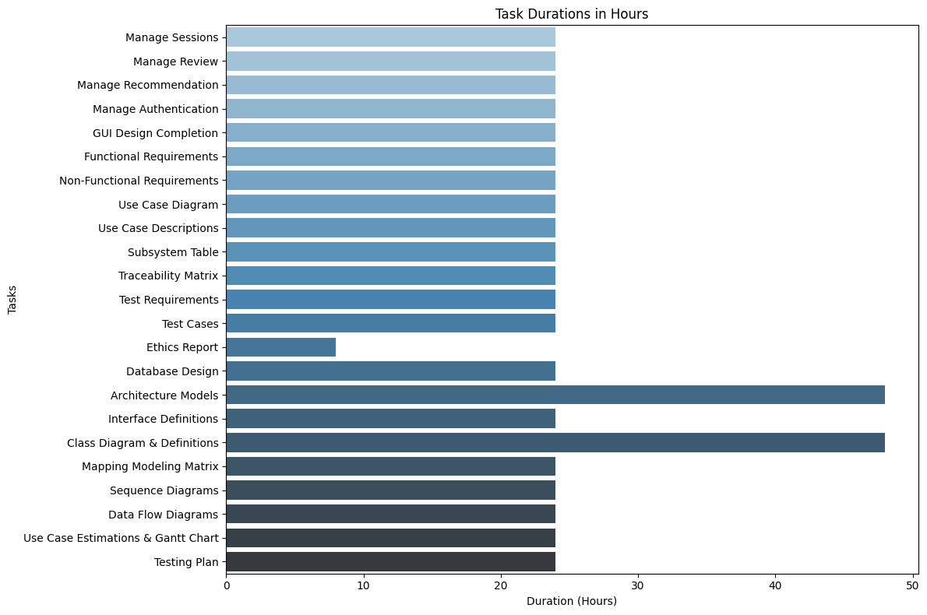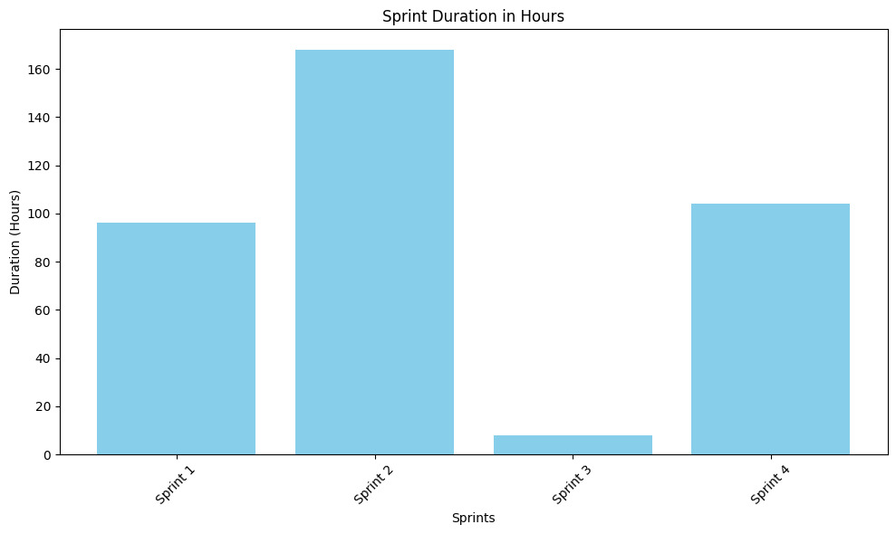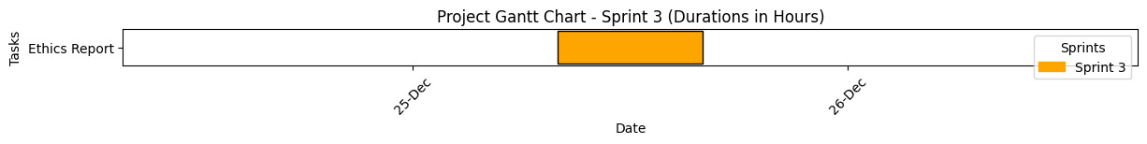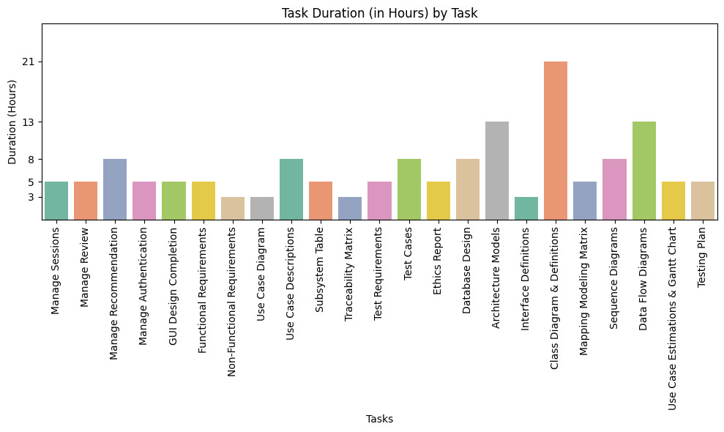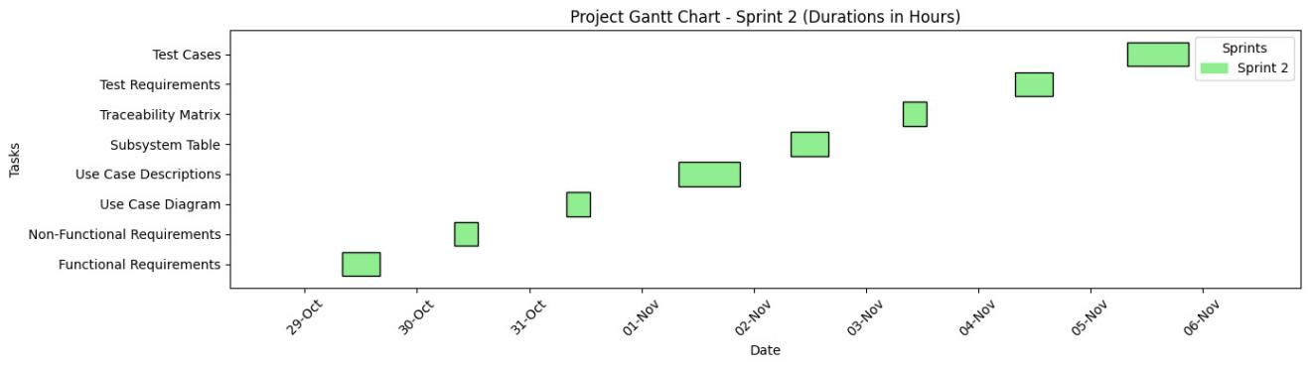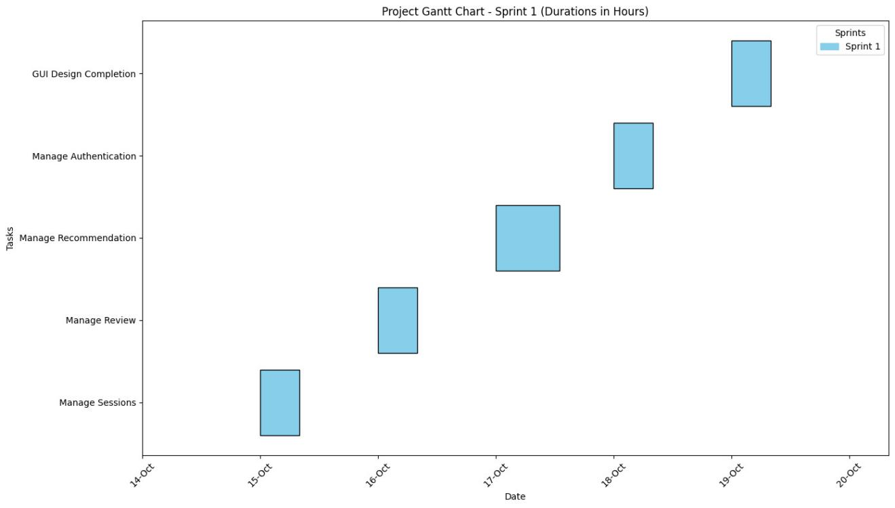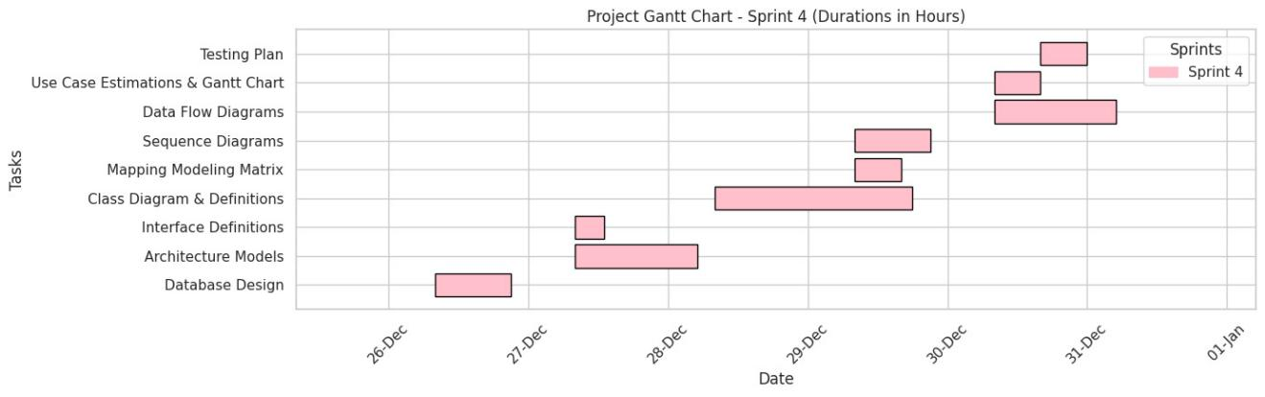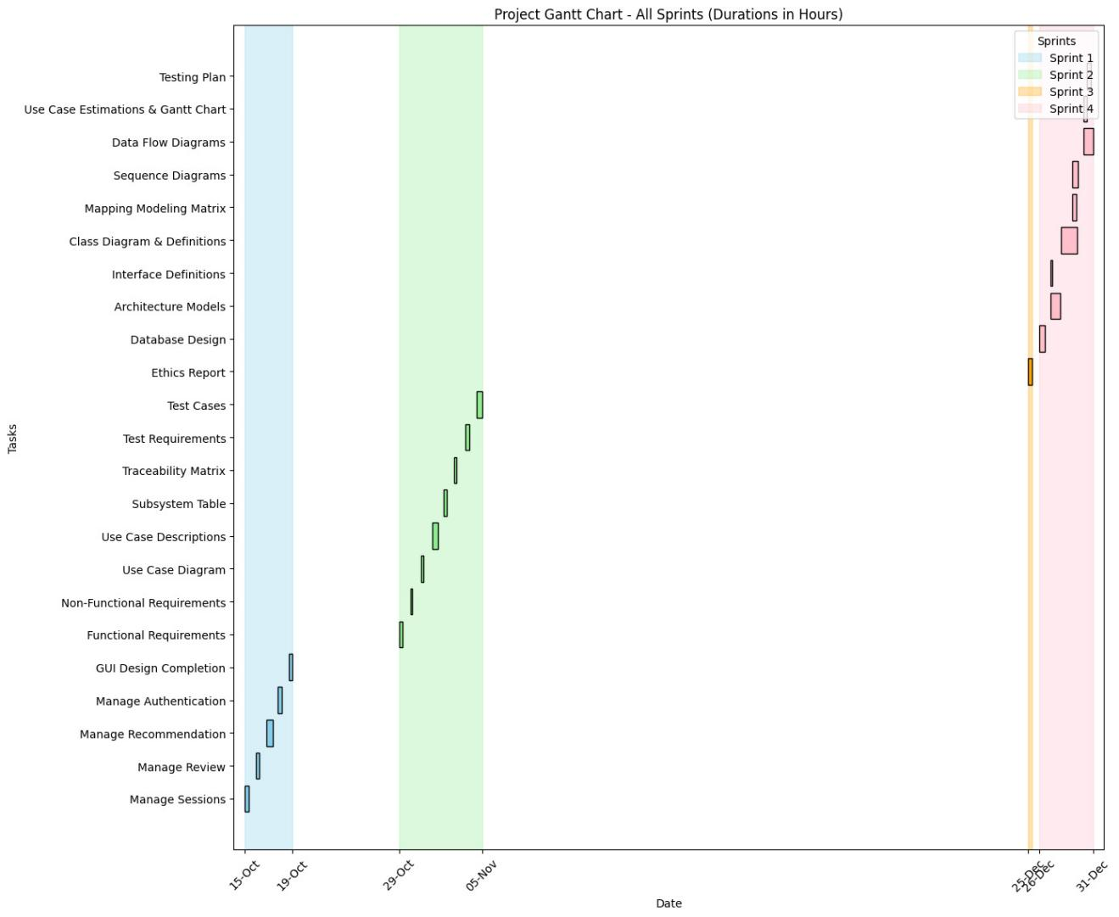

- Test plan

Order of our use cases

- Manage authentication
- Manage profile
- Manage subscribers
- Specialized Subscriber Management
- Manage premium subscribers
- Manage coach subscribers
- Manage doctor subscribers
- Manage booking
- Manage sessions
- Manage chat
- Content and Engagement
- Manage social media content
- Manage notification
- Manage user interaction
- Manage goal
- Manage progress
- Manage Inbody
- Feedback and Recommendations
- Manage review
- Manage rating
- Manage recommendation
- Manage nutrition intake
- Manage payment

Test plan

- Unit test (Manage authentication)
- Regression test (Manage authentication)
- Unit test (Manage profile)
- Regression test (Manage profile)
- Integration test (Manage authentication, Manage profile)
- Regression test (Manage authentication, Manage profile)
- Unit test (Manage subscribers)
- Regression test (Manage subscribers)
- Integration test (Manage authentication, Manage profile, Manage subscribers)
- Regression test (Manage authentication, Manage profile, Manage subscribers)
- Unit test (Manage booking)
- Regression test (Manage booking)
- Integration test (Manage authentication, Manage profile, Manage booking)
- Regression test (Manage authentication, Manage profile, Manage booking)
- Unit test (Manage sessions)
- Regression test (Manage sessions)
- Integration test (Manage booking, Manage sessions)
- Regression test (Manage booking, Manage sessions)
- Unit test (Manage social media content)
- Regression test (Manage social media content)
- Unit test (Manage notification)
- Regression test (Manage notification)
- Integration test (Manage social media content, Manage notification)
- Regression test (Manage social media content, Manage notification)
- Unit test (Manage goal)
- Regression test (Manage goal)
- Unit test (Manage progress)
- Regression test (Manage progress)
- Integration test (Manage goal, Manage progress)
- Regression test (Manage goal, Manage progress)
- Unit test (Manage inbody)
- Regression test (Manage inbody)
- Integration test (Manage goal, Manage progress, Manage inbody)
- Regression test (Manage goal, Manage progress, Manage inbody)
- Unit test (Manage review)
- Regression test (Manage review)
- Unit test (Manage rating)
- Regression test (Manage rating)
- Integration test (Manage review, Manage rating)
- Regression test (Manage review, Manage rating)
- Unit test (Manage recommendation)
- Regression test (Manage recommendation)
- Integration test (Manage review, Manage rating, Manage recommendation)
- Regression test (Manage review, Manage rating, Manage recommendation)
- Unit test (Manage nutrition intake)
- Regression test (Manage nutrition intake)
- Unit test (Manage payment)
- Regression test (Manage payment)
- Integration test (Manage nutrition intake, Manage payment)
- Regression test (Manage nutrition intake, Manage payment)
- Unit test (Manage chat)
- Regression test (Manage chat)
- Integration test (Manage payment, Manage chat)
- Regression test (Manage payment, Manage chat)
- Unit test (Manage coach subscribers)
- Regression test (Manage coach subscribers)
- Unit test (Manage doctor subscribers)
- Regression test (Manage doctor subscribers)
- Unit test (Manage premium subscribers)
- Regression test (Manage premium subscribers)
- Integration test (Manage subscribers, Manage coach subscribers, Manage doctor subscribers, Manage premium subscribers)
- Regression test (Manage subscribers, Manage coach subscribers, Manage doctor subscribers, Manage premium subscribers)
- Unit test (Manage user interaction)
- Regression test (Manage user interaction)
- Integration test (Manage social media content, Manage notification, Manage user interaction)
- Regression test (Manage social media content, Manage notification, Manage user interaction)
- System testing (All use cases)
- Configuration testing (All use cases)
- Installation testing (All use cases)
- Usability testing (All use cases)
- Security testing (All use cases)
- Stress testing (All use cases)
- Stability testing (All use cases)
- Alpha testing (All use cases)
- Beta testing (All use cases)
- Acceptance testing (All use cases)

Explanation
1. Unit test (Manage authentication)
Explanation: This test checks the individual functionality of the Manage authentication feature. It ensures that the authentication process, including login, registration, and validation, works as expected.
2. Regression test (Manage authentication)
Explanation: This test ensures that changes or updates made to the Manage authentication feature don't break any previously working functionalities in the system, such as login, registration, and password recovery.
3. Unit test (Manage profile)
Explanation: Tests the Manage profile feature in isolation, validating that users can correctly update, view, and manage their profiles, such as name, email, and preferences.
4. Regression test (Manage profile)
Explanation: Verifies that updates or changes made to the Manage profile feature do not negatively impact the rest of the system or any previously working functions, such as user data management.
5. Integration test (Manage authentication, Manage profile)
Explanation: Tests the integration between Manage authentication and Manage profile features. For example, after successful login, users should be able to navigate to their profiles and view/edit their information.
6. Regression test (Manage authentication, Manage profile)
Explanation: Ensures that no unintended side effects occur in either Manage authentication or Manage profile when modifications are made, and that the integration between the two features continues to work smoothly.

7. Unit test (Manage subscribers)
Explanation: Tests the functionality of managing subscribers (e.g., adding, removing, and viewing subscriber data), ensuring each action works as expected.
8. Regression test (Manage subscribers)
Explanation: Ensures that changes made to the Manage subscribers feature do not interfere with other parts of the system, especially the Manage authentication and Manage profile features.
9. Integration test (Manage authentication, Manage profile, Manage subscribers)
Explanation: Tests the combined functionality of Manage authentication, Manage profile, and Manage subscribers. It ensures that users can log in, access their profiles, and manage their subscriptions seamlessly.
10. Regression test (Manage authentication, Manage profile, Manage subscribers)
Explanation: Verifies that updates to any of the features do not affect the overall flow between Manage authentication, Manage profile, and Manage subscribers, ensuring all features work together properly.

11. Unit test (Manage booking)
Explanation: Tests the individual functionality of the Manage booking feature, ensuring users can book, modify, and cancel reservations without issues.

12. Regression test (Manage booking)
Explanation: Ensures that no changes to the Manage booking feature break its functionality, or any of its integrations with other features like Manage profile and Manage subscribers.
13. Integration test (Manage authentication, Manage profile, Manage booking)
Explanation: Tests how Manage authentication, Manage profile, and Manage booking work together. For example, after logging in and viewing their profile, users should be able to book reservations.
14. Regression test (Manage authentication, Manage profile, Manage booking)
Explanation: Checks that any changes made to Manage booking don't interfere with Manage authentication and Manage profile, ensuring smooth functionality across all features.

15. Unit test (Manage sessions)
Explanation: Tests the Manage sessions feature to ensure that users can start, manage, and end sessions without issues.
16. Regression test (Manage sessions)
Explanation: Ensures that changes to the Manage sessions feature do not break the existing functionality of the system, particularly in relation to other features like Manage booking.
17. Integration test (Manage booking, Manage sessions)
Explanation: Tests the integration between Manage booking and Manage sessions. For instance, once a user books a session, they should be able to manage it and track its status.
18. Regression test (Manage booking, Manage sessions)
Explanation: Verifies that modifications to either Manage booking or Manage sessions don't disrupt their interaction or the user experience.
19. Unit test (Manage social media content)
Explanation: Tests the functionality of the Manage social media content feature, ensuring users can post, edit, and delete content without issues.
20. Regression test (Manage social media content)
Explanation: Ensures that updates to Manage social media content do not affect other features, including profile management or authentication.
21. Unit test (Manage notification)
Explanation: Tests the Manage notification feature to verify that notifications are triggered and received correctly by users.
22. Regression test (Manage notification)
Explanation: Ensures that any changes made to the Manage notification feature do not disrupt the overall system's notification delivery, including integration with Manage profile and Manage booking.
23. Integration test (Manage social media content, Manage notification)
Explanation: Tests how Manage social media content and Manage notification work together. For instance, posting new content on social media might trigger a notification.
24. Regression test (Manage social media content, Manage notification)
Explanation: Ensures that modifications to Manage social media content or Manage notification do not negatively affect the integration between the two features.
25. Unit test (Manage goal)
Explanation: Verifies the functionality of Manage goal, allowing users to set, update, and track their personal goals (e.g., fitness goals).
26. Regression test (Manage goal)
Explanation: Ensures that changes made to Manage goal do not affect other features or the user’s ability to track their goals.
27. Unit test (Manage progress)
Explanation: Tests the functionality of the Manage progress feature, ensuring users can track and view their progress toward their goals.
28. Regression test (Manage progress)
Explanation: Verifies that updates to Manage progress do not interfere with other features like Manage goal or Manage sessions.
29. Integration test (Manage goal, Manage progress)
Explanation: Tests the combined functionality of Manage goal and Manage progress. For instance, as users update their progress, their goals should automatically reflect those changes.
30. Regression test (Manage goal, Manage progress)
Explanation: Ensures that any changes to Manage goal or Manage progress do not affect their integration or disrupt the overall functionality of the app.
31. Unit test (Manage inbody)
Explanation: Tests the Manage inbody feature, which may track metrics like weight, body fat percentage, and muscle mass.
32. Regression test (Manage inbody)
Explanation: Ensures that changes to Manage inbody do not affect its interaction with other features, such as goal tracking or progress.
33. Integration test (Manage goal, Manage progress, Manage inbody)
Explanation: Tests the integration between Manage goal, Manage progress, and Manage inbody to ensure metrics and goals are tracked and updated correctly.
34. Regression test (Manage goal, Manage progress, Manage inbody)
Explanation: Verifies that updates made to any of these features do not break their interaction, ensuring that all related data is handled properly.
35. Unit test (Manage review)
Explanation: This test verifies the functionality of the Manage review feature, ensuring users can write, submit, and view reviews for services or products without issues.
36. Regression test (Manage review)
Explanation: Ensures that any updates or changes made to the Manage review feature do not negatively impact the system's existing functionality or other related features like Manage rating.
37. Unit test (Manage rating)
Explanation: Tests the Manage rating feature, ensuring users can rate services, products, or experiences accurately and that the ratings are correctly saved and displayed.
38. Regression test (Manage rating)
Explanation: Ensures that modifications to the Manage rating feature do not cause any issues in the application or affect other features like Manage review or Manage goal.
39. Integration test (Manage review, Manage rating)
Explanation: Verifies the combined functionality of Manage review and Manage rating. For example, when a user submits a review, they should be able to rate the service, and both the review and rating should be saved properly.
40. Regression test (Manage review, Manage rating)
Explanation: Ensures that any changes made to either Manage review or Manage rating do not interfere with the interaction between them or cause issues with other features.
41. Unit test (Manage recommendation)
Explanation: Tests the Manage recommendation feature, ensuring users can receive and view product or service recommendations based on their preferences or behavior.
42. Regression test (Manage recommendation)
Explanation: Ensures that updates to the Manage recommendation feature do not break its functionality or interfere with other features, such as Manage rating or Manage social media content.
43. Integration test (Manage review, Manage rating, Manage recommendation)
Explanation: Verifies that Manage review, Manage rating, and Manage recommendation work together. For example, user reviews and ratings should influence the recommendations they receive.
44. Regression test (Manage review, Manage rating, Manage recommendation)
Explanation: Ensures that changes to Manage review, Manage rating, or Manage recommendation do not cause issues with their interaction or with other features.
45. Unit test (Manage nutrition intake)
Explanation: Verifies the Manage nutrition intake feature, ensuring users can log and track their daily food intake, calorie consumption, and other dietary data accurately.
46. Regression test (Manage nutrition intake)
Explanation: Ensures that updates to the Manage nutrition intake feature do not disrupt the overall functionality or integration with other features like Manage goal or Manage progress.
47. Unit test (Manage payment)
Explanation: Tests the Manage payment feature to ensure that users can make, view, and process payments correctly, including integration with payment gateways.
48. Regression test (Manage payment)
Explanation: Ensures that modifications to Manage payment do not break the functionality of the payment processing system or affect the user experience.
49. Integration test (Manage nutrition intake, Manage payment)
Explanation: Tests how Manage nutrition intake and Manage payment interact. For example, users may need to pay for premium nutrition tracking services.
50. Regression test (Manage nutrition intake, Manage payment)
Explanation: Ensures that any updates made to either Manage nutrition intake or Manage payment do not cause problems in their integration.
51. Unit test (Manage chat)
Explanation: Verifies the Manage chat feature, ensuring users can send, receive, and view messages within the app.
52. Regression test (Manage chat)
Explanation: Ensures that changes to Manage chat do not interfere with other features, especially those that involve communication or social interaction.
53. Integration test (Manage payment, Manage chat)
Explanation: Tests the combined functionality of Manage payment and Manage chat, ensuring that users can chat with service providers and make payments seamlessly during interactions.
54. Regression test (Manage payment, Manage chat)
Explanation: Ensures that changes to either Manage payment or Manage chat do not affect their integration or break the overall flow of the system.
55. Unit test (Manage coach subscribers)
Explanation: Tests the functionality of Manage coach subscribers, ensuring that coaches can manage and view their subscribers.
56. Regression test (Manage coach subscribers)
Explanation: Ensures that changes to Manage coach subscribers do not break the functionality or cause issues with related features.
57. Unit test (Manage doctor subscribers)
Explanation: Verifies the Manage doctor subscribers feature, allowing doctors to manage and view their subscribers.
58. Regression test (Manage doctor subscribers)
Explanation: Ensures that updates to Manage doctor subscribers do not affect its functionality or interfere with other features like Manage profile or Manage subscribers.
59. Unit test (Manage premium subscribers)
Explanation: Verifies the Manage premium subscribers feature, ensuring that premium users can access special features and that their subscription status is correctly managed.
60. Regression test (Manage premium subscribers)
Explanation: Ensures that updates to Manage premium subscribers do not break premium subscription functionality or interfere with user access to premium features.
61. Integration test (Manage subscribers, Manage coach subscribers, Manage doctor subscribers, Manage premium subscribers)
Explanation: Tests the combined functionality of Manage subscribers, Manage coach subscribers, Manage doctor subscribers, and Manage premium subscribers, ensuring that all subscription types are managed correctly.
62. Regression test (Manage subscribers, Manage coach subscribers, Manage doctor subscribers, Manage premium subscribers)
Explanation: Ensures that updates made to any of the subscription management features do not cause issues with how users are managed across different subscription categories.
63. Unit test (Manage user interaction)
Explanation: Tests the Manage user interaction feature, verifying that users can interact with the app’s various components and features as intended.
64. Regression test (Manage user interaction)
Explanation: Ensures that updates to Manage user interaction do not interfere with user experience or cause issues in the system.
65. Integration test (Manage social media content, Manage notification, Manage user interaction)
Explanation: Tests how Manage social media content, Manage notification, and Manage user interaction work together, ensuring users receive notifications about social media posts and interact with them effectively.
66. Regression test (Manage social media content, Manage notification, Manage user interaction)
Explanation: Ensures that changes made to these features do not break their interaction and that notifications and user interactions work seamlessly across all components.
67. System Testing (All use cases)
Explanation: Tests the entire system to ensure all components and features work together as expected and that the system meets the specified requirements.
68. Configuration Testing (All use cases)
Explanation: Ensures that the application works in different system environments, configurations, and setups, confirming that it functions properly across various hardware and software configurations.
69. Installation Testing (All use cases)
Explanation: Verifies that the installation process works smoothly and that the system installs correctly on all supported platforms.
70. Usability Testing (All use cases)
Explanation: Evaluates the ease of use and user-friendliness of the application, ensuring that users can navigate and interact with the app intuitively.
71. Security Testing (All use cases)
Explanation: Ensures that the system is secure, protecting user data, authentication, and payment information from potential vulnerabilities and threats.
72. Stress Testing (All use cases)
Explanation: Tests how the system handles high levels of stress, such as large numbers of users or heavy data processing, to ensure it remains functional under load.
73. Stability Testing (All use cases)
Explanation: Verifies that the system remains stable over time and under prolonged use, ensuring that it does not crash or experience significant performance issues.
74. Alpha Testing (All use cases)
Explanation: An early testing phase where the system is tested by the internal development team to identify major bugs and issues before releasing to external testers.
75. Beta Testing (All use cases)
Explanation: Involves releasing the application to a group of external users (beta testers) to test the system in real-world environments and identify any remaining bugs or issues.
76. Acceptance Testing (All use cases)
Explanation: A final phase of testing to ensure that the system meets the business requirements and is ready for release to the end-users. It confirms that the app is fit for purpose and works as intended.

Another test plan (some changes)

- Unit test (Manage authentication)
- Regression test (Manage authentication)
- Unit test (Manage profile)
- Regression test (Manage authentication, Manage profile)
- Integration test (Manage authentication, Manage profile)
- Regression test (Manage authentication, Manage profile)
- Unit test (Manage subscribers)
- Regression test (Manage authentication, Manage profile, Manage subscribers)
- Integration test (Manage authentication, Manage profile, Manage subscribers)
- Regression test (Manage authentication, Manage profile, Manage subscribers)
- Unit test (Manage booking)
- Regression test (Manage authentication, Manage profile, Manage subscribers, Manage booking)
- Integration test (Manage authentication, Manage profile, Manage subscribers, Manage booking)
- Regression test (Manage authentication, Manage profile, Manage subscribers, Manage booking)
- Unit test (Manage sessions)
- Regression test (Manage authentication, Manage profile, Manage subscribers, Manage booking, Manage sessions)
- Integration test (Manage authentication, Manage profile, Manage subscribers, Manage booking, Manage sessions)
- Regression test (Manage authentication, Manage profile, Manage subscribers, Manage booking, Manage sessions)
- Unit test (Manage social media content)
- Regression test (Manage authentication, Manage profile, Manage subscribers, Manage booking, Manage sessions, Manage social media content)
- Integration test (Manage authentication, Manage profile, Manage subscribers, Manage booking, Manage sessions, Manage social media content)
- Regression test (Manage authentication, Manage profile, Manage subscribers, Manage booking, Manage sessions, Manage social media content)
- Unit test (Manage notification)
- Regression test (Manage authentication, Manage profile, Manage subscribers, Manage booking, Manage sessions, Manage social media content, Manage notification)
- Integration test (Manage authentication, Manage profile, Manage subscribers, Manage booking, Manage sessions, Manage social media content, Manage notification)
- Regression test (Manage authentication, Manage profile, Manage subscribers, Manage booking, Manage sessions, Manage social media content, Manage notification)
- Unit test (Manage goal)
- Regression test (Manage authentication, Manage profile, Manage subscribers, Manage booking, Manage sessions, Manage social media content, Manage notification, Manage goal)
- Integration test (Manage authentication, Manage profile, Manage subscribers, Manage booking, Manage sessions, Manage social media content, Manage notification, Manage goal)
- Regression test (Manage authentication, Manage profile, Manage subscribers, Manage booking, Manage sessions, Manage social media content, Manage notification, Manage goal)
- Unit test (Manage progress)
- Regression test (Manage authentication, Manage profile, Manage subscribers, Manage booking, Manage sessions, Manage social media content, Manage notification, Manage goal, Manage progress)
- Integration test (Manage authentication, Manage profile, Manage subscribers, Manage booking, Manage sessions, Manage social media content, Manage notification, Manage goal, Manage progress)
- Regression test (Manage authentication, Manage profile, Manage subscribers, Manage booking, Manage sessions, Manage social media content, Manage notification, Manage goal, Manage progress)
- Unit test (Manage inbody)
- Regression test (Manage authentication, Manage profile, Manage subscribers, Manage booking, Manage sessions, Manage social media content, Manage notification, Manage goal, Manage progress, Manage inbody)
- Integration test (Manage authentication, Manage profile, Manage subscribers, Manage booking, Manage sessions, Manage social media content, Manage notification, Manage goal, Manage progress, Manage inbody)
- Regression test (Manage authentication, Manage profile, Manage subscribers, Manage booking, Manage sessions, Manage social media content, Manage notification, Manage goal, Manage progress, Manage inbody)
- Unit test (Manage review)
- Regression test (Manage authentication, Manage profile, Manage subscribers, Manage booking, Manage sessions, Manage social media content, Manage notification, Manage goal, Manage progress, Manage inbody, Manage review)
- Integration test (Manage authentication, Manage profile, Manage subscribers, Manage booking, Manage sessions, Manage social media content, Manage notification, Manage goal, Manage progress, Manage inbody, Manage review)
- Regression test (Manage authentication, Manage profile, Manage subscribers, Manage booking, Manage sessions, Manage social media content, Manage notification, Manage goal, Manage progress, Manage inbody, Manage review)
- Unit test (Manage rating)
- Regression test (Manage authentication, Manage profile, Manage subscribers, Manage booking, Manage sessions, Manage social media content, Manage notification, Manage goal, Manage progress, Manage inbody, Manage review, Manage rating)
- Integration test (Manage authentication, Manage profile, Manage subscribers, Manage booking, Manage sessions, Manage social media content, Manage notification, Manage goal, Manage progress, Manage inbody, Manage review, Manage rating)
- Regression test (Manage authentication, Manage profile, Manage subscribers, Manage booking, Manage sessions, Manage social media content, Manage notification, Manage goal, Manage progress, Manage inbody, Manage review, Manage rating)
- Unit test (Manage recommendation)
- Regression test (Manage authentication, Manage profile, Manage subscribers, Manage booking, Manage sessions, Manage social media content, Manage notification, Manage goal, Manage progress, Manage inbody, Manage review, Manage rating, Manage recommendation)
- Integration test (Manage authentication, Manage profile, Manage subscribers, Manage booking, Manage sessions, Manage social media content, Manage notification, Manage goal, Manage progres, Manage inbody, Manage review, Manage rating, Manage recommendation)
- Regression test (Manage authentication, Manage profile, Manage subscribers, Manage booking, Manage sessions, Manage social media content, Manage notification, Manage goal, Manage progress, Manage inbody, Manage review, Manage rating, Manage recommendation)
- Unit test (Manage nutrition intake)
- Regression test (Manage authentication, Manage profile, Manage subscribers, Manage booking, Manage sessions, Manage social media content, Manage notification, Manage goal, Manage progress, Manage inbody, Manage review, Manage rating, Manage recommendation, Manage nutrition intake)
- Integration test (Manage authentication, Manage profile, Manage subscribers, Manage booking, Manage sessions, Manage social media content, Manage notification, Manage goal, Manage progress, Manage inbody, Manage review, Manage rating, Manage recommendation, Manage nutrition intake)
- Regression test (Manage authentication, Manage profile, Manage subscribers, Manage booking, Manage sessions, Manage social media content, Manage notification, Manage goal, Manage progress, Manage inbody, Manage review, Manage rating, Manage recommendation, Manage nutrition intake)
- Unit test (Manage payment)
- Regression test (Manage authentication, Manage profile, Manage subscribers, Manage booking, Manage sessions, Manage social media content, Manage notification, Manage goal, Manage progress, Manage inbody, Manage review, Manage rating, Manage recommendation, Manage nutrition intake, Manage payment)
- Integration test (Manage authentication, Manage profile, Manage subscribers, Manage booking, Manage sessions, Manage social media content, Manage notification, Manage goal, Manage progress, Manage inbody, Manage review, Manage rating, Manage recommendation, Manage nutrition intake, Manage payment)
- Regression test (Manage authentication, Manage profile, Manage subscribers, Manage booking, Manage sessions, Manage social media content, Manage notification, Manage goal, Manage progress, Manage inbody, Manage review, Manage rating, Manage recommendation, Manage nutrition intake, Manage payment)
- Unit test (Manage chat)
- Regression test (Manage authentication, Manage profile, Manage subscribers, Manage booking, Manage sessions, Manage social media content, Manage notification, Manage goal, Manage progress, Manage inbody, Manage review, Manage rating, Manage recommendation, Manage nutrition intake, Manage payment, Manage chat)
- Integration test (Manage authentication, Manage profile, Manage subscribers, Manage booking, Manage sessions, Manage social media content, Manage notification, Manage goal, Manage progress, Manage inbody, Manage review, Manage rating, Manage recommendation, Manage nutrition intake, Manage payment, Manage chat)
- Regression test (Manage authentication, Manage profile, Manage subscribers, Manage booking, Manage sessions, Manage social media content, Manage notification, Manage goal, Manage progress, Manage inbody, Manage review, Manage rating, Manage recommendation, Manage nutrition intake, Manage payment, Manage chat)
- Unit test (Manage coach subscribers)
- Regression test (Manage authentication, Manage profile, Manage subscribers, Manage booking, Manage sessions, Manage social media content, Manage notification, Manage goal, Manage progress, Manage inbody, Manage review, Manage rating, Manage recommendation, Manage nutrition intake, Manage payment, Manage chat, Manage coach subscribers)
- Integration test (Manage authentication, Manage profile, Manage subscribers, Manage booking, Manage sessions, Manage social media content, Manage notification, Manage goal, Manage progress, Manage inbody, Manage review, Manage rating, Manage recommendation, Manage nutrition intake, Manage payment, Manage chat, Manage coach subscribers)
- Regression test (Manage authentication, Manage profile, Manage subscribers, Manage booking, Manage sessions, Manage social media content, Manage notification, Manage goal, Manage progress, Manage inbody, Manage review, Manage rating, Manage recommendation, Manage nutrition intake, Manage payment, Manage chat, Manage coach subscribers)
- Unit test (Manage doctor subscribers)
- Regression test (Manage authentication, Manage profile, Manage subscribers, Manage booking, Manage sessions, Manage social media content, Manage notification, Manage goal, Manage progress, Manage inbody, Manage review, Manage rating, Manage recommendation, Manage nutrition intake, Manage payment, Manage chat, Manage coach subscribers, Manage doctor subscribers)

- Integration test (Manage authentication, Manage profile, Manage subscribers, Manage booking, Manage sessions, Manage social media content, Manage notification, Manage goal, Manage progress, Manage inbody, Manage review, Manage rating, Manage recommendation, Manage nutrition intake, Manage payment, Manage chat, Manage coach subscribers, Manage doctor subscribers)
- Regression test (Manage authentication, Manage profile, Manage subscribers, Manage booking, Manage sessions, Manage social media content, Manage notification, Manage goal, Manage progress, Manage inbody, Manage review, Manage rating, Manage recommendation, Manage nutrition intake, Manage payment, Manage chat, Manage coach subscribers, Manage doctor subscribers)
- Unit test (Manage premium subscribers)
- Regression test (Manage authentication, Manage profile, Manage subscribers, Manage booking, Manage sessions, Manage social media content, Manage notification, Manage goal, Manage progress, Manage inbody, Manage review, Manage rating, Manage recommendation, Manage nutrition intake, Manage payment, Manage chat, Manage coach subscribers, Manage doctor subscribers, Manage premium subscribers)
- Integration test (Manage authentication, Manage profile, Manage subscribers, Manage booking, Manage sessions, Manage social media content, Manage notification, Manage goal, Manage progress, Manage inbody, Manage review, Manage rating, Manage recommendation, Manage nutrition intake, Manage payment, Manage chat, Manage coach subscribers, Manage doctor subscribers, Manage premium subscribers)
- Regression test (Manage authentication, Manage profile, Manage subscribers, Manage booking, Manage sessions, Manage social media content, Manage notification, Manage goal, Manage progress, Manage inbody, Manage review, Manage rating, Manage recommendation, Manage nutrition intake, Manage payment, Manage chat, Manage coach subscribers, Manage doctor subscribers, Manage premium subscribers)
- Unit test (Manage user interaction)
- Regression test (Manage authentication, Manage profile, Manage subscribers, Manage booking, Manage sessions, Manage social media content, Manage notification, Manage goal, Manage progress, Manage inbody, Manage review, Manage rating, Manage recommendation, Manage nutrition intake, Manage payment, Manage chat, Manage coach subscribers, Manage doctor subscribers, Manage premium subscribers, Manage user interaction)
- Integration test (Manage authentication, Manage profile, Manage subscribers, Manage booking, Manage sessions, Manage social media content, Manage notification, Manage goal, Manage progress, Manage inbody, Manage review, Manage rating, Manage recommendation, Manage nutrition intake, Manage payment, Manage chat, Manage coach subscribers, Manage doctor subscribers, Manage premium subscribers, Manage user interaction)
- Regression test (Manage authentication, Manage profile, Manage subscribers, Manage booking, Manage sessions, Manage social media content, Manage notification, Manage goal, Manage progress, Manage inbody, Manage review, Manage rating, Manage recommendation, Manage nutrition intake, Manage payment, Manage chat, Manage coach subscribers, Manage doctor subscribers, Manage premium subscribers, Manage user interaction)
- System testing (All use cases)
- Configuration testing (All use cases)
- Installation testing (All use cases)
- Usability testing (All use cases)
- Security testing (All use cases)
- Stress testing (All use cases)
- Stability testing (All use cases)
- Alpha testing (All use cases)
- Beta testing (All use cases)
- Acceptance testing (All use cases)

- Ethics

1- What are the software ethics principles that you adopted?
We adopted the following ethical principles to ensure the project aligns with professional standards and benefits the end users:
- Public Interest: The application prioritizes user health and well-being, ensuring accessibility to fitness and nutrition resources while safeguarding user data privacy.
- Product Integrity: The application ensures accuracy in health recommendations and transparency in subscription and billing practices.
- Data Privacy and Security: User data is securely stored with encryption and complies with relevant data protection regulations such as GDPR.
- Fairness and Inclusivity: The platform provides gender-specific coaching options and does not discriminate against any user group.
- COLLEAGUES: our team members were fair and supportive of each other.
- SELF: our team members always search and learn any new skill needed.

2- How did you apply recognized ethics principles? Showing the ethical alternatives and their consequences and which action did you choose?
Application of Ethics Principles in Project Design
Public Interest
Scenario: Designing the communication protocol between the client and server to ensure secure data transmission.
Ethical Alternatives:
Use plain text for simplicity but risk exposing sensitive user data.
Implement encryption (e.g., SSL/TLS) to secure data transmission.
Chosen Action: Incorporated encryption in the design to protect user data during communication, prioritizing security and public interest.
Client and Employer Interest

Scenario: Balancing the design complexity with resource constraints for both client and server sides.
Ethical Alternatives:
Design a feature-rich interface that could strain server resources.
opt for a modular design with essential features that can scale based on resource availability.
Chosen Action: Created a modular design with scalability, aligning with client interests and ensuring future maintainability.
Product Quality

Scenario: Deciding between a pre-built UI framework and a custom JavaFX design for the user interfaces.
Ethical Alternatives:
Use a pre-built framework for faster design at the cost of flexibility.
Design a custom UI tailored to project requirements, ensuring usability and consistency.
Chosen Action: Designed a custom JavaFX interface that meets specific project needs, ensuring usability and product quality.
Professional Judgment

Scenario: During the design phase, a team member suggested adding experimental features not aligned with initial requirements.
Ethical Alternatives:
Include the experimental features, risking scope creep and potential design inconsistencies.
Focus on the approved requirements and document additional ideas for future iterations.
Chosen Action: Adhered to the initial requirements, ensuring a focused design while documenting experimental features for future consideration.
Ethical Project Management

Scenario: Deciding how to allocate design responsibilities among team members with varying expertise.
Ethical Alternatives:
Assign tasks without considering individual strengths, risking inefficiency.
Match tasks to team members' expertise while providing opportunities for skill growth.
Chosen Action: Allocated responsibilities based on expertise and provided mentorship opportunities, fostering ethical collaboration.
Advancing the Profession

Scenario: Incorporating best practices for client-server communication, such as following industry standards for API design.
Ethical Alternatives:
Use non-standardized approaches for quicker design.
Adhere to established API design principles, ensuring compatibility and scalability.
Chosen Action: Followed industry standards for API design, ensuring the system is robust and professionally developed.

3- Clearly mention what documents sources and references you used, and how any license/copyright/legal/privacy are handled?
Sources and References Used in Project Design Documents and Resources:
Lectures:
We used our lectures content to apply the theoretical concepts of them on our project design
Labs and tutorials:
We also used our labs and tutorials content in performing our project
Additional Search and YouTube and AI tools:
You used those resources for clarifying and understanding the tasks we need to perform.
Handling Licenses, Copyright, and Legal/Privacy Issues:
For the licenses and copy rights we didn’t use any material or any tool that we must mention their copyrights or anything like that we just used them for understanding and we just applied them in our way on our project.

- GUI
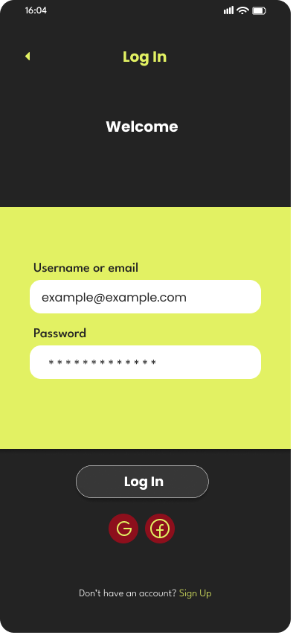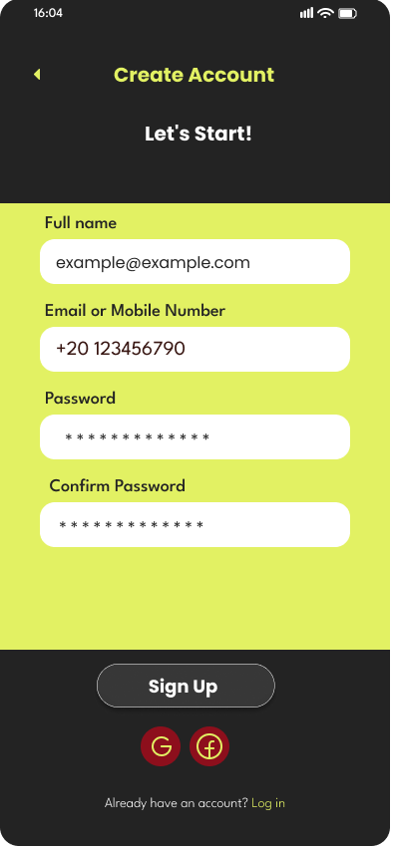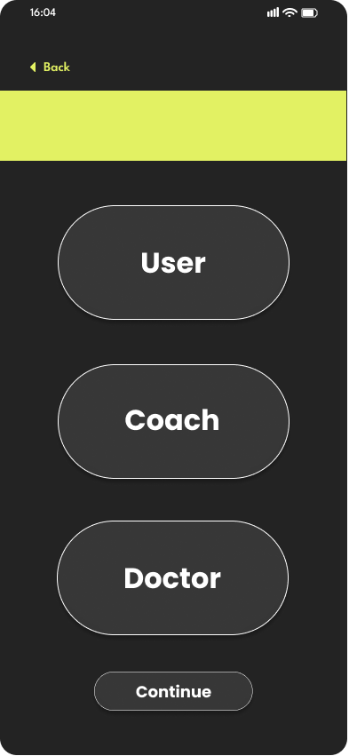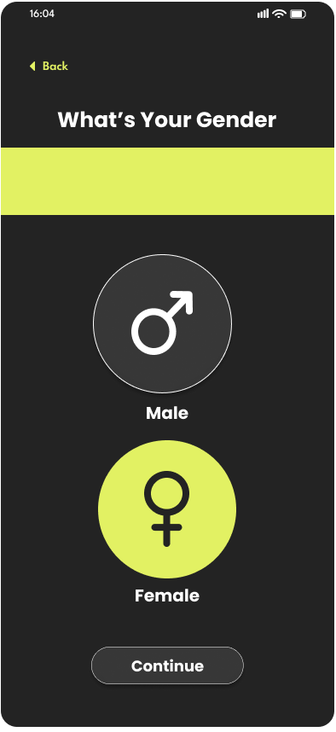
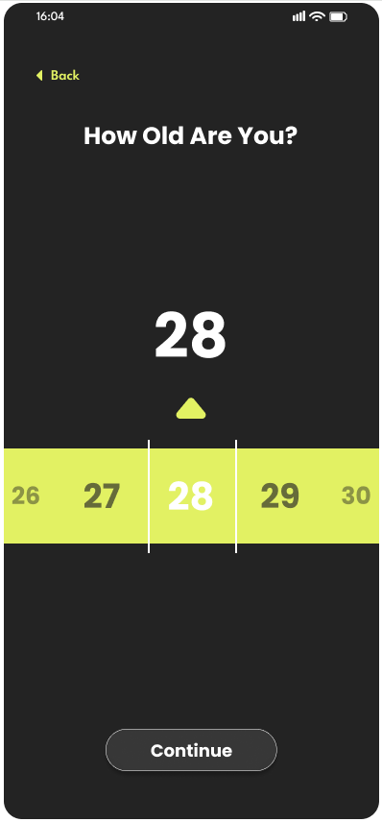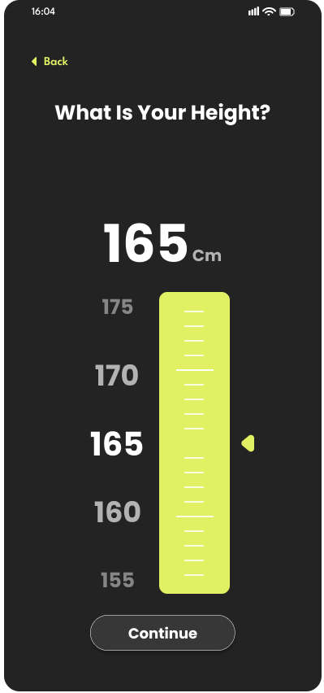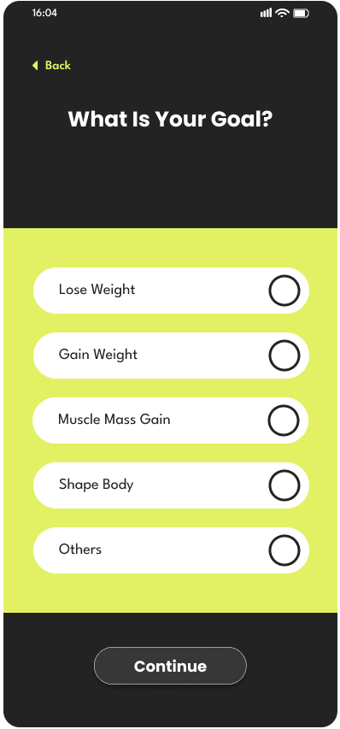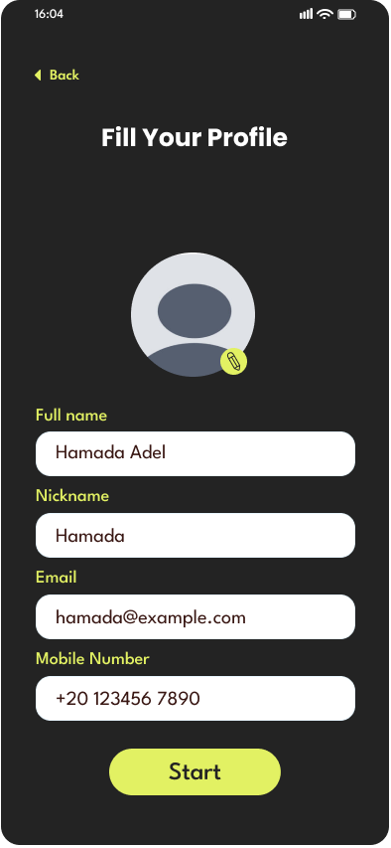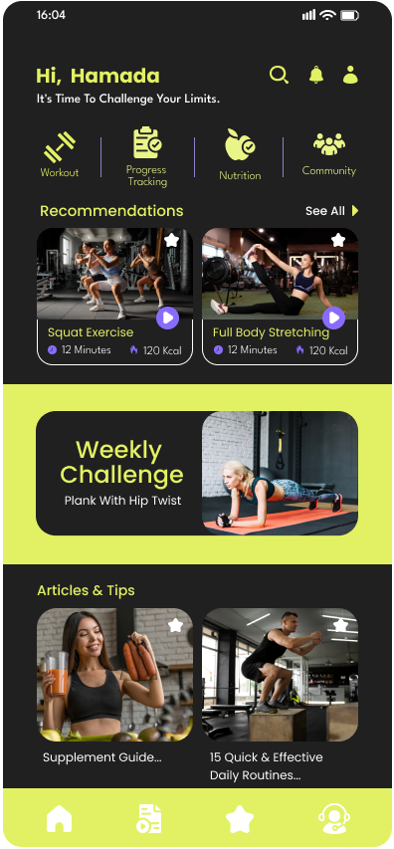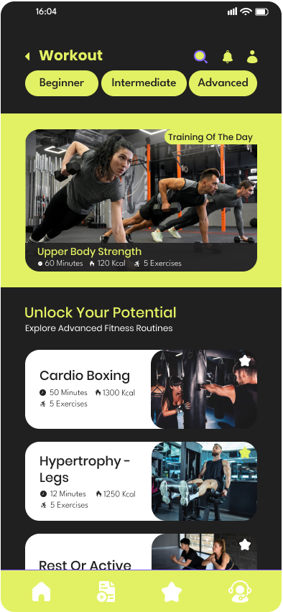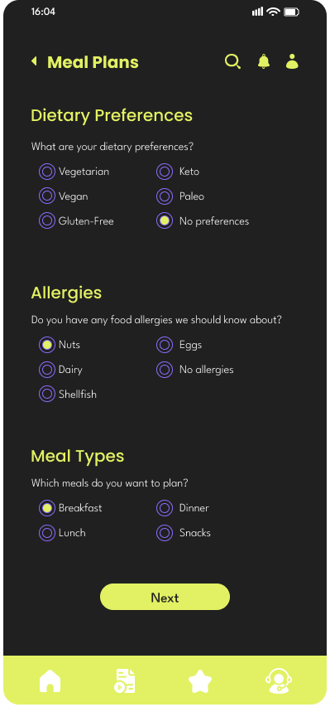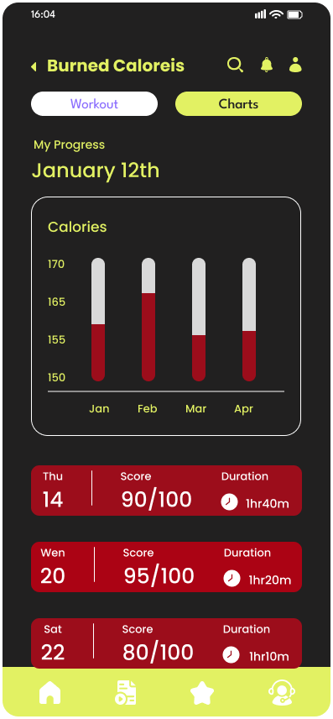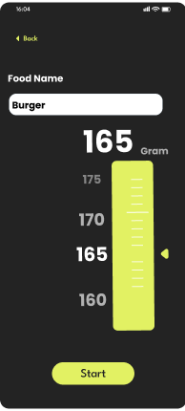 n”